

Remote Learning Policy
For the purpose of school closure and non-attendance due to isolation, medical restrictions or suspension.

Reviewed on |  | Sept 26 |  | Review frequency |  | Annually
Next review due |  | Sept 27 |  | Template Yes / No |  | Yes
Owner |  | Russell Slatford |  | Approved by |  | Executive

History of Policy Changes
Date | Page | Change | Origin of Change
July 26 |  | No change to template policy | N/A

Contents
1. History of Policy Changes 2
2. Contents 2
3. Introduction 3
4. Aims 3
5. Context 4
6. Hamwic Trust Expectations 5
7. Safeguarding 6
8. Delivering remote education safely 6
9. General 7
10. Monitoring & Review 7
11. Appendices 8

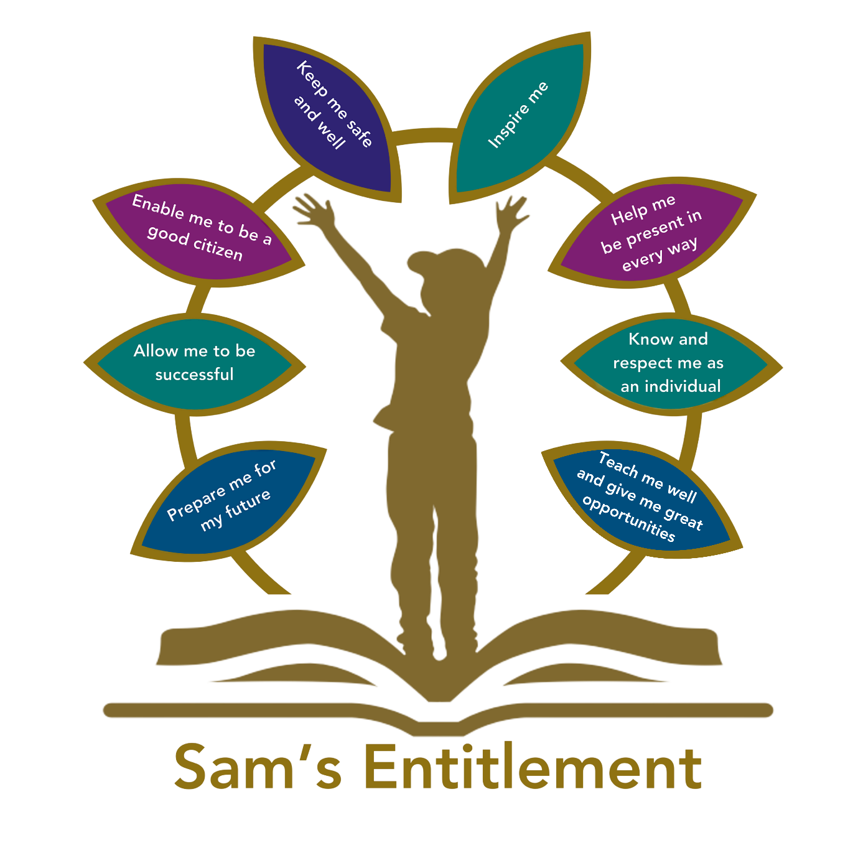

Introduction
“Hamwic Education Trust (HET) believe that all pupils should receive a high quality, enriching, learning experience in a safe and inclusive environment, which promotes excellence through a broad curriculum that prepares them for their future and opens doors to a diverse array of opportunities as well as that all pupils and adults within HET flourish as individuals and together.” This policy sets out how pupils will be enabled to learn should school have to close or if a pupil is unable to attend school for an extended period but is well enough to access online learning.

Aims
- To ensure there is a planned approach for any 1:1 remote learning
- To set out expectations of staff providing remote learning
- To set out expectations of children and parents receiving remote learning
- To provide appropriate safeguarding and data protection guidelines

Context
Remote learning can be an effective tool for pupils unable to attend school due to long term sickness or medical conditions that prevent children from attending school. In exceptional cases, it can also support the reintegration of those pupils whose attendance needs to increase. In the case of school closure, remote education ensures the continuity of learning is not disturbed. Where remote education is used it will be relevant to the school context and it should take into account the following:
- Consideration of age, stage of development, and independent study skills.
- Any SEND or other additional needs the pupils might have.
- The pupils’ home environment, which includes having a suitable place and opportunity to study.
- Screen time, making reasonable allowances for adequate breaks for pupils and staff during digital remote education.
- Any significant demands on parents’ or carers’ help or support. Younger children, especially pupils in primary schools and some children with SEND, might require high levels of adult involvement to support their engagement with remote education, which can make it a particular challenge for these groups.
- Ensure that the LA has been informed where absence for medical reasons is above 15 days.
- Schools should also ensure that they have explored all support the LA has to offer for pupils not attending for medical reasons.
And, follow the principles below.
- For those pupils who are well enough to access a full-time education from home, the remote education provided should be equivalent in length to the core teaching pupils would receive in school and will include recorded or live direct teaching time, and time for pupils to complete tasks and assignments independently. In this case, the amount of remote education provided should be, as a minimum:
  - Key Stage 1: 3 hours a day on average across the cohort, with less for younger children
  - Key Stage 2: 4 hours a day
  - Key Stages 3 and 4: 5 hours a day

- For those children who are not well enough to access a full curriculum at home, schools should work in co-production with parents and the child to ensure an appropriate offer is in place. Where possible, the teaching of basic skills in reading, writing and maths should take priority. This offer should be reviewed regularly.

- When planning and delivering remote education:
  - Teach a planned and well-sequenced curriculum so that knowledge and skills are built incrementally, with a good level of clarity about what is intended to be taught and practised in each subject so that pupils can progress through the school’s curriculum.
  - Select a digital platform for remote education provision that will be used consistently across the school in order to allow interaction, assessment and feedback and make sure staff are trained and confident in its use.

- Overcome barriers to digital access for pupils by:
  - Distributing school-owned laptops accompanied by a user agreement or contract.
  - Providing printed resources, such as textbooks and workbooks, to structure learning, supplemented with other forms of communication to keep pupils on track or answer questions about work.

- Have systems for checking, whether pupils are engaging with their work, and work with families to rapidly identify effective solutions where engagement is a concern. The Seesaw learning platform will be used to support this.

- Identify a named senior leader with overarching responsibility for the quality and delivery of remote education, including that provision meets expectations for remote education.

Hamwic Trust Expectations
In addition to the above guidelines, the Hamwic Trust Executive have set the expectation that:
Where recorded lessons are being used from externals sources, such as the Hamwic Online YouTube site, Oak Academy or the BBC teaching programme, schools will ensure there is some personal contact from the school to the child at least twice weekly to ensure the child continues to feel part of the school.
Roles and responsibilities within the remote learning
Task | Expectation | Responsibility
Live lessons and 1:1 lessons | - Adults will deliver lessons in a setting with a neutral background  - Where possible, pupils should work in an open area rather than within their bedroom  - Children will be asked to join with cameras on and unmuted  - For primary children, an adult at home will be asked to be present while the child joins lessons and until the teacher acknowledges the parent  - 1:1 lessons will require a parent present at the beginning and end of a session.  - Adults will be dressed professionally  - Children are expected to be dressed appropriately for lessons (uniform is not required)  - The school may record lessons for the purpose of safeguarding staff and pupils. If this is the case, lessons will be stored on the school rather than personal networks or equipment. Teachers do not have permission to circulate lessons or place them on social media  - The behaviour policy will be used in remote live lessons as it would be in school. Parents will be informed of any disruptive or inappropriate behaviour  - Pupils and parents do not have permission from teachers to record live lessons or redistribute them in any way. Any recordings that are made and circulated to others, including via social media, will be reported and managed under GDPR law. | Teacher / TA
Check remote learning is being accessed, completed and checked for accuracy | - Check the work submitted on Seesaw and who has been online to attempt work.  - Respond to any emailed/chat function questions from children. Provide summary feedback to pupils about how they are getting on with their work at least weekly.  - Ensure some lessons give children immediate feedback through teacher checking or self-marking answer sheets | Class teacher, or teacher uploading remote learning
Contact vulnerable children working at home | - A video or telephone call should be made home twice each week. Wherever possible speak to the child and not just the parent. | TA/Pastoral/SEN/office
Ensure the learning platform is robust | - Check the network connection in school is working well each day  - Ensure children have the necessary IT equipment and stationery to work remotely. | Business manager/IT manager
Ensure safeguarding concerns are being monitored and addressed as per the CP policy | - Ensure staff are clear of how to report any safeguarding concerns they become aware of when children are learning from home.  - Ensure children are aware of how to report any concerns they have about online content.  - Ensure all children carry out an online safety update/assembly at least fortnightly  - Ensure children with CP concerns are taught in school. If this is not possible, ensure that there are regular sightings of the child. | DSL/DDSL/pastoral lead

Safeguarding
- Staff are required to alert the Designated Safeguarding Lead (DSL) if they have any concerns about a child’s welfare during a period of remote learning
- The school will continue to engage with social services and attend meetings where necessary
- Any parent who wishes to raise a safeguarding concern should do this in the usual way via the school office who will put them in contact with the DSL or Headteacher
- The school will ensure that online safety is referenced regularly within a period of remote learning. Parents will be reminded of the need to ensure their child is only accessing appropriate content while away from school and that personal data is being protected.
https://www.bbc.co.uk/newsround/44074704
- Pupils are encouraged to communicate through the remote platform/school email system rather than by personal email. Where a child uses a personal email, the teacher will ensure that any response also copies in the parent (or line manager if the parent email isn’t available)

Delivering remote education safely
- Keeping children safe online is essential.
- Guidance on safeguarding and remote education can be found in the safeguarding policy.

Free school meals and remote education
Where pupils eligible for benefits-related free school meals are receiving remote education, schools should work with their school catering team or caterer either to help provide good quality lunch parcels or to issue a food voucher if available. This will ensure that eligible pupils continue to be supported for the period they are unable to attend school. More information on free school meals can be found at Free school meals: guidance for schools and local authorities - GOV.UK (www.gov.uk)

Remote education during a suspension or permanent exclusion
Headteachers should take steps to ensure that work is set and marked for pupils during the first five school days of a suspension or permanent exclusion. Remote education should not be used as a justification for sending pupils home due to their misbehaviour. Any time a pupil is sent home due to disciplinary reasons, this is a suspension and must be done in line with the law on disciplinary suspensions. This is the case even if they have been asked to log on or access online education while suspended.

Provision for pupils with SEND
If pupils with SEND are not able to attend school and require remote education, their teachers are best placed to know how their needs can most effectively be met to ensure that they continue to access the curriculum. The school needs to put in place an appropriate curriculum, teaching and support that will enable the pupil to continue learning effectively. Some pupils with SEND may not be able to access remote education without adult support. Schools should work collaboratively with families and put arrangements in place that allow pupils with SEND to access remote education successfully. In this situation, decisions on how provision can be delivered should be informed by relevant considerations including the support families will require and types of services that the pupil can access remotely.

General
Schools should consider sharing any up-to-date procedures and plans in place with parents, carers and pupils in order to provide ongoing clarity and transparency about what to expect from remote education if it is required. It is up to schools to decide how they share remote education information with parents, carers and pupils. Some schools continue to maintain pages on their websites providing information and guidance about remote education provision and links to any trusted external education websites. This is not a requirement, but it can be helpful for parents or carers and pupils to access if required.
Further information is available from:
Providing remote education: non-statutory guidance for schools

Monitoring & Review
This policy will be reviewed annually by the owner

Appendices



