

Relationships Education, Relationships Sex Education (RSE)

Reviewed on |  | 2026/27, Term 1 |  | Review frequency |  | Annual
Next review due |  | 2027/28, Term 1 |  | Template Yes / No |  | Yes
Owner |  | Dir of Ed, Secondary and Primary |  | Approved by |  | Board of Trustees

History of Policy Changes

Date | Page | Change | Origin of Change
Sep 26 | All | Combined primary and secondary into one policy using the Browne Jacobson template.  Summary of changes:  The revised DfE Relationships Education, Relationships and Sex Education (RSE) and Health Education Guidance becomes statutory from 1 September 2026 and replaces the 2019 guidance.  The most significant change is a stronger safeguarding focus, particularly in relation to the online world. Schools are now expected to teach pupils about online harms, misinformation, AI-generated content, deepfakes, online scams, pornography, and the influence of misogynistic and incel cultures.  In primary schools, there is greater emphasis on online safety, personal boundaries, consent in age-appropriate contexts, communication skills, resilience, bereavement and loss, and teaching accurate anatomical terminology. Schools are strongly encouraged to include same-sex parents and a range of family structures when teaching about relationships and families.  In secondary schools, new content includes AI literacy, sexual ethics, misogyny, respectful relationships, pornography, and the impact of harmful online influences. Teaching on sexual and reproductive health has been expanded to include menstrual and gynaecological health, such as endometriosis and PCOS, fertility, menopause, contraception and accessing healthcare services.  The DfE has removed the previously proposed age restrictions on sensitive topics, instead requiring schools to use professional judgement to ensure content is age and stage appropriate. The guidance also clarifies teaching about biological sex, gender reassignment, equality and respect.  Schools must review and update their RSHE policies and curriculum arrangements before September 2026. | Annual Review
Sep 25 | All  All | References to Governing Body changed to Local Governing Committee | Annual Review
Sep 25 | All  All | References to Headteacher changed to School Leader | Annual Review
Sep 25 | All  All | Due to the adoption of Browne Jacobson’s template, this review is ‘wholesale’ and the document should be reviewed in its entirety, before approval. | Annual Review

1. Introduction 4
2. Aims and Objectives 5
3. Definition of Relationships Education and Relationships & Sex Education (RSE) 6
4. Roles and responsibilities 6
5. Delivery of Relationships Education, RSE and Health Education 8
6. Relationships education and RSE: Curriculum and outcomes 9
7. Health education: Physical health and mental well-being 9
8. Pupils with special educational needs and/or disabilities 9
9. Working with Parents/Carers and the Wider Community 10
10. Right to Request Withdrawal from Sex Education 10
11. Flexibility 10
12. Monitoring of RSE 11
13. Confidentiality and Child Protection 11
14. Equal opportunities 12
15. Complaints 12
Appendix 1 Relationships education primary stage curriculum and outcomes 13
Appendix 3 Health education primary stage curriculum and outcomes 17
Appendix 4 Health Education Secondary Stage Curriculum and Outcomes 21

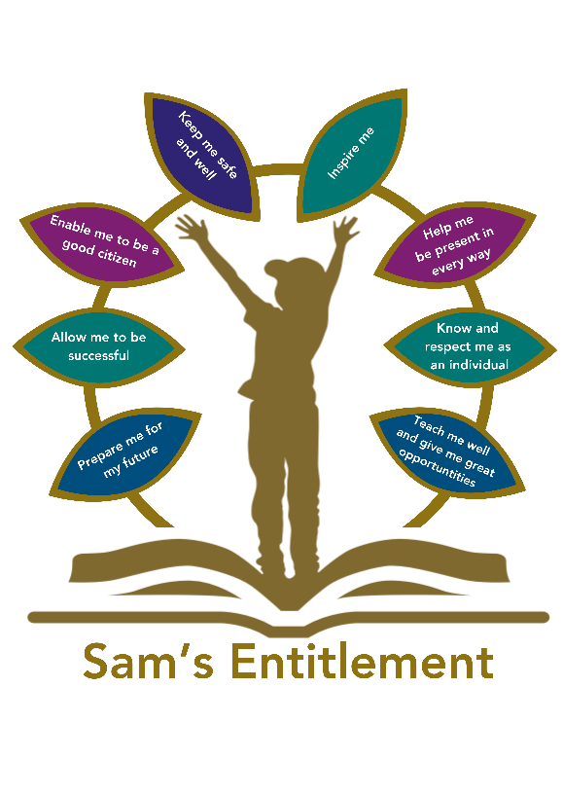

Introduction

Hamwic Education Trust (HET) believe that all pupils should receive a high quality, enriching, learning experience in a safe and inclusive environment, which promotes excellence through a broad curriculum that prepares them for their future and opens doors to a diverse array of opportunities as well as that all pupils and adults within HET flourish as individuals and together.” HET believes that to prepare for the opportunities and responsibilities of adult life, children and young people need to have the knowledge, skills and self-confidence to make informed and ethical decisions about their wellbeing, health, and relationships. Relationships education and relationships and sex education (RSE) is about giving children and young people the information they need to help them develop healthy, nurturing relationships of all kinds, not just intimate relationships. Health education is giving pupils information to make well-informed, positive choices about their own health and wellbeing. HET recognises that physical health and mental wellbeing are interlinked, and it is important that pupils can recognise when things are not right in their own health or the health of others and can seek support when needed.

HET has a responsibility under the Equality Act 2010 to ensure the best for all pupils at its schools irrespective of disability, educational needs, race, nationality, ethnic or national origin, sex, gender identity, pregnancy, maternity, religion, or sexual orientation. Relationships education, RSE and health education will be taught in a way which is sensitive to the different needs of individual pupils and may need to adapt and change over time to reflect the needs of the particular cohort.

HET is aware of the need to be mindful of, and respectful to a wide variety of faith and cultural beliefs across its schools and will make every attempt to be appropriately sensitive. Equally, it is essential that children and young people still have access to the learning they need to stay safe, healthy, and understand their rights as individuals. HET believes that its pupils deserve the right to honest, clear, and impartial scientific and factual information to help better form their own beliefs and values, free from bias, judgement, or subjective personal beliefs of those who teach them.

HET will ensure pupils understand the importance of equality and respect and that they learn about all protected characteristics, including sexual orientation and gender reassignment, by the end of their secondary education. The teaching of lesbian, gay, bisexual and transgender content will be sensitive and age appropriate and will be fully integrated into programmes of study for this area of the curriculum rather than delivered as a standalone unit or lesson. HET is mindful that beyond the facts and the law about biological sex and gender reassignment there is significant debate, and will be careful not to endorse any particular view or teach it as fact. However, HET will ensure pupils are taught to recognise that all those with a protected characteristic should be treated with dignity and respect.

This policy advocates a curriculum which supports a whole-school culture, challenging everyday sexism, misogyny, homophobia and stereotypes, avoiding language that stigmatises boys, and ensuring pupils understand links between misogyny and violence against women and girls.

This policy has been developed in consultation (at school-level) with parents, pupils, and staff from all schools within HET to ensure that it meets the needs of the whole HET community.

The policy will be reviewed annually, and parents will be consulted in advance about significant changes.

Aims and Objectives

  - Through the delivery of high quality, evidence-based and age-appropriate relationships education, RSE and health education, HET aims to help prepare pupils for the onset of puberty, give them an understanding of sexual development and the importance of health and hygiene, create a positive culture in relation to sexuality and relationships and to ensure pupils know how and when to ask for help and where to access support. By the end of their education HET hopes pupils will have developed resilience and feelings of self-respect, confidence, and empathy in preparation for the responsibilities and experiences of adult life.
Relationships education, RSE and health education are intended to help pupils to:
- Build healthy, respectful relationships focusing on family and friends.
- Understand how to be healthy and be aware of potential risk areas (such as drugs and alcohol).
- Learn about intimate relationships and sex.
- Learn about mental wellbeing.
Develop key personal attributes, such as kindness, integrity, generosity, and honesty.

Definition of Relationships Education and Relationships & Sex Education (RSE)

  - Relationships education at primary phase is about teaching the fundamental building blocks and characteristics of positive relationships, with particular reference to friendships, family relationships, and relationships with other children and with adults and who can support them. It includes how to take turns, how to treat each other with kindness, consideration and respect, the importance of honesty and truthfulness, permission seeking and giving, and the concept of personal privacy, establishing personal space and boundaries. Relationships education doesn’t involve explaining the detail of different forms of sexual activity but can cover sensitive topics such as sexual violence in order to keep children safe.

RSE is lifelong learning about physical, sexual, moral, and emotional development. It is about teaching sex, sexuality and sexual health in a way that gives pupils the confidence to make sound decisions when facing risks and other challenges. It includes teaching about friendship, the importance of caring, stable, and mutually supportive relationships with another person, and how to control and understand feelings that come with being in a relationship.

RSE does not encourage early sexual experimentation. It teaches children and young people to understand human sexuality and to respect themselves and others, to build self-esteem and understand the reasons for delaying sexual activity so that they can develop safe, fulfilling, and healthy sexual relationships, at the appropriate time.

RSE will outline that there are different types of committed, stable relationships, the characteristics and legal status of other types of long-term relationships, the importance of marriage as a relationship choice and why it must be freely entered into, how relationships might contribute to human happiness and their importance for raising children, as well as highlighting the roles and responsibilities of parents with respect to raising children, characteristics of successful parenting and how to judge when relationships have become unsafe as well as how to seek help or advice and report concerns about others.

Roles and responsibilities

All members of the HET community are expected to follow this policy. Roles, responsibilities, and expectations of each section of HET and school community are set out in detail below.

  - Board of Trustees

Trustees will monitor and evaluate the impact of the policy by reviewing pupils’ progress in achieving the expected educational outcomes. They will hold the Chief Executive Officer (CEO) and School Leaders (SL) to account for the implementation of the policy. This includes monitoring and evaluating the religious ethos of the schools where this applies.

  - The Chief Executive Officer

The CEO will ensure that Relationships Education, RSE, and Health Education is taught consistently across the schools within HET and will report back to the Board of Trustees on educational outcomes. They will ensure that senior staff receive regular professional development training in how to deliver relationships education, RSE and health education.

  - Local Governing Committee

Local Governors at Harefield Primary School will review and monitor the application and implementation of this policy by receiving regular reports from the SL on educational outcomes.

Each SL, with support from their respective Senior Leadership Team (SLT), will ensure that staff are supported and up to date with policy changes. They will ensure that Relationships Education, RSE and Health Education are well led, effectively managed and well planned across various subjects (to avoid unnecessary duplication of topics) and that the quality of provision is subject to regular and effective self-evaluation. The SL will ensure that teaching is age-appropriate, delivered in ways that are accessible to all pupils with SEND, and that the subjects are resourced, staffed, and timetabled appropriately. They will ensure that teaching delivered by any external organisation is age-appropriate and accessible for pupils and will liaise with parents about any concerns or opinions regarding Relationships Education, RSE and Health Education provision and will manage parental requests for withdrawal of pupils from non-statutory, non-science components of relationships education, RSE and health education.

  - Staff

Teachers of Relationships Education, RSE and Health Education will ensure that they are up to date with school policy and curriculum requirements regarding sex education and will attend and engage in professional development training. Teachers will encourage pupils to communicate concerns regarding their social, personal, and emotional development in confidence, listen to their needs, and support them seriously. If a pupil comes to a member of staff with an issue that the member of staff feels they are not able to deal with alone, they will take this concern to their line manager.

  - Working with external agencies

Working with external organisations can enhance delivery of these subjects, bringing in specialist knowledge and different ways of engaging with young people.

As with any visitor, schools are responsible for ensuring that they check the visitor or visiting organisation’s credentials. Harefield Primary School will ensure that the teaching delivered by the visitor fits with their planned programme and their published policy. Visitors will be asked to show the materials they will use as well as a lesson plan in advance, to ensure it meets the full range of pupils’ needs (e.g. special educational needs). How confidentiality will work in any lesson will be agreed in advance and the school will ensure that the visitor understands how safeguarding reports should be dealt with in line with school policy.

Use of visitors should be to enhance teaching by an appropriate member of the teaching staff, rather than as a replacement for teaching by those staff.

  - Parents

Harefield Primary School aims to build a positive and supporting relationship with parents through mutual understanding, cooperation, and trust. Parents are expected to share the responsibility of sex education and support their children’s personal, social, and emotional development. Harefield Primary School hopes parents will create an open home environment where pupils can engage, discuss, and continue to learn about matters that have been raised through school. Parents are also encouraged to seek additional support from Harefield Primary School if they feel it is needed.

  - Pupils

Pupils are expected to take Relationships Education, RSE and Health Education seriously. Pupils are expected to listen, be considerate of other pupils’ feelings and beliefs, comply with class-set confidentiality rules and support one another with issues that arise during class. Pupils who fail to follow these standards of behaviour will be dealt with under the HET Behaviour Policy.

Delivery of Relationships Education, RSE and Health Education

  - Relationships Education, RSE and Health Education will be delivered in a non-judgmental, factual way allowing scope for children and young people to ask questions in a safe environment. Teachers will tailor the delivery of Relationships Education, RSE and Health Education to meet the specific needs of the pupils in that class, and to be responsive to their behaviour and development. Classes will explore different attitudes, values, and social labels, and develop skills that will enable our pupils to make informed decisions regarding sex and relationships as well as being able to differentiate between fact, opinion and belief and an understanding of the law on various topics. Pupils will be taught the anatomically correct names for body parts, but slang or everyday terms used in certain social circles will be discussed; this will surround discussion about what is and is not acceptable language to use. Relationships and Health Education (RHE) is taught through weekly lessons linked to the SCARF personal, social and health education programme and links with the whole school assembly programme. An overview of the broad topics covered, and the linked Relationship and Health objectives can be found in Appendix 2.

Staff will ensure that all resources used in the delivery of Relationships Education, RSE and Health Education are appropriate for the age and needs of their pupils. Examples of these resources are included in the annexes of this policy.

Harefield Primary School believe that working with external organisations can enhance the delivery of Relationships Education, RSE and Health Education and details of external providers used are included in the annexes of this policy.

Primary schools:

In Harefield Primary School, Relationships and Citizenship Education will be delivered in weekly PSHE lesson. Biological elements are taught within the relevant Science units. All computing units include related coverage of online safety and how this impacts on emotional well-being. As a Rights Respecting School, we also cover citizenship and safety in all assemblies and through our Pupil Voice groups. Children of the same age may be developmentally at different stages, leading to differing types of questions or behaviours. Staff will use teaching methods that take account of these differences and the potential for discussion on a one-to-one basis or in small groups.

Relationships education and RSE: Curriculum and outcomes

  - By the end of primary, Harefield Primary School will cover the content set out in Annex 1.

Harefield Primary School recognises that pupils may ask questions about topics which go beyond any sex education covered by the school, or which relate to sex education from which they have been withdrawn. Harefield Primary School recognises that children may turn to inappropriate sources of information, including online, when they have unanswered questions. Staff will use different strategies to handle these questions, which may include anonymous question boxes and offering alternative trusted members of staff to talk to (e.g. the ELSA team).

  - Curriculum materials can be viewed on request.

Health education: Physical health and mental well-being

  - Harefield Primary School wishes to promote pupils’ health and wellbeing by encouraging self-control, their ability to self-regulate and strategies for doing so. This will enable pupils to become confident in their ability to achieve well and persevere even when they encounter setbacks, or when their goals are distant, and to respond calmly and rationally to setbacks and challenges. Harefield Primary School believes that an integrated, whole-school approach to the teaching and promotion of health and wellbeing will have a positive impact on behaviour and attainment. Health education will be delivered in science, computing, physical education (PE) and personal, social, health and economic education (PSHEE).

By the end of primary Harefield Primary School will cover the content set out at Annex 3.

Curriculum materials can be viewed on the Curriculum pages of the school website or on request.

Pupils with special educational needs and/or disabilities

  - Harefield Primary School will endeavour to ensure that relationships education, RSE, and health education is accessible for all pupils. We are aware that some pupils are more vulnerable to exploitation, bullying and other issues due to the nature of their SEND. Relationships education, RSE and health education may be particularly important for such pupils, for example those with social, emotional and mental health needs or learning disabilities. Teaching will be sensitive, age-appropriate, developmentally appropriate, differentiated and personalised to meet the specific needs of pupils at different developmental stages.

Working with Parents/Carers and the Wider Community

Harefield Primary School will work closely with parents when planning and delivering these subjects. We will ensure that parents know what will be taught and when, and clearly communicate the fact that parents have the right to request that their child be withdrawn from some or all of sex education delivered as part of statutory RSE.

Harefield Primary School will proactively engage parents, consult when developing and reviewing the policy, and share all RSHE materials on request, including materials from external providers. copyright should not be used as a reason to refuse parental access, and that schools may use a parent portal or presentation route with appropriate copyright safeguards.

Parents should be given every opportunity to understand the purpose and content of Relationships Education and RSE. We will ensure that there are good communication and opportunities for parents to understand and ask questions about the school’s approach help secure their confidence in the curriculum.

Right to Request Withdrawal from Sex Education

  - Harefield Primary School hopes that parents will feel comfortable with, and understand the importance of, the education provided to their children as described in this policy.

Parents of children at Harefield Primary School have the right to withdraw their child from sex education and should state this in writing and send it to Sian Carr (head teacher). Primary schools will automatically grant withdrawal from sex education, except if included in the science curriculum. Parents of children in secondary schools have the right to request that their child be withdrawn from some or all of the sex education aspects of RSE.

Before withdrawing or making a request, HET strongly urges parents to carefully consider their decision, as sex education is a vital part of the school curriculum and supports child development. Parents cannot withdraw their child from relationships education or health education or the elements on human growth and reproduction which fall under the science curriculum.

If a pupil is excused from sex education, Harefield Primary School will ensure that the pupil receives appropriate, purposeful education during the period of withdrawal.

Flexibility

  - Harefield Primary School will retain freedom to determine an age-appropriate, developmental curriculum which meets the needs of young people, is developed in consultation with parents and the local community. Schools must also comply with the relevant provisions under the Equality Act 2010 and DfE statutory guidance.

  - Flexibility is important as it allows schools to respond to local public health and community issues, meet the needs of their community and adapt materials and programmes to meet the needs of pupils (for example in teaching about gangs or high local prevalence of specific sexually transmitted infections).

Monitoring of RSE

The delivery of RSE is monitored by Senior Leaders and HET Safeguarding Reviews to ensure provision can be further strengthened. The RSE leader carries out monitoring through:

Planning scrutiny
Lesson observations
Analysis of pupils’ work and discussions with pupils
Monitoring of SEN plans and IEPs where appropriate
Sampling of pupils’ end of year reports
Pupil interviews

Confidentiality and Child Protection

  - HET hopes to provide a safe and supportive school community where pupils feel comfortable seeking help and guidance on anything that may be concerning them about life either at school or at home. All teachers will receive training around confidentiality and should ensure that pupils understand that they cannot offer unconditional confidentiality. If a child protection issue is disclosed to a member of staff, that member of staff should follow the HET Child Protection and Safeguarding Procedures.

If a staff member is approached by a pupil under 16 who is having, or is contemplating having sexual intercourse, the teacher should:

- Ensure that the pupil is accessing all the contraceptive and sexual health advice available and understands the risks of being sexually active.
- Encourage the pupil to talk to their parent or carer. Pupils may feel that they are more comfortable bringing these issues to a teacher they trust, but it is important that children and their parents have open and trusting relationships when it comes to sexual health and the school will encourage this as much as possible.
- Decide whether there is a child protection issue. This may be the case if the teacher is concerned that there is coercion or abuse involved. If a member of staff is informed that a pupil under 13 is having, or is contemplating having sexual intercourse, this will be dealt with under child protection procedures.
Pupils with special educational needs may be more vulnerable to exploitation and less able to protect themselves from harmful influences. If staff are concerned that this is the case, they should seek support from the designated safeguarding lead, to decide what is in the best interest of the child.

Harefield Primary School must ensure that Relationships Education, RSE and Health Education is accessible for all pupils. This is particularly important when planning teaching for pupils with special educational needs and disabilities who represent a large minority of pupils. High-quality teaching that is differentiated and personalised will be the starting point to ensure accessibility. Harefield Primary School will be mindful of the preparing for adulthood outcomes, as set out in the SEND code of practice, when teaching these subjects to those with SEND.

Equal opportunities

  - Relationships Education, RSE and Health Education will be delivered equally to both genders, normally in mixed classes. There are, however, certain topics that may be delivered in single sex groupings, e.g. menstruation and personal hygiene.

HET has a commitment to ensure that Relationships Education, RSE and Health Education is relevant to all pupils and is taught in a way that is age and stage appropriate. Pupils are encouraged to openly and freely discuss diversity of personal, social and sexual preferences. Prejudiced views will be challenged, and equality promoted. Any bullying that relates to sexual behaviour or perceived sexual orientation will be dealt with swiftly and seriously in accordance with the Harefield Primary School behaviour policy.

Complaints

If parents have any concerns or complaints over the application or implementation of this policy, they should raise their concerns with a staff member or the SL in accordance with the HET Complaints Policy.

Appendix 1 Relationships education primary stage curriculum and outcomes
PSHE Association Programme of Study for PSHE Education (Key stages 1–5), Jan 2020.pdf
Harefield Primary School - PSHE
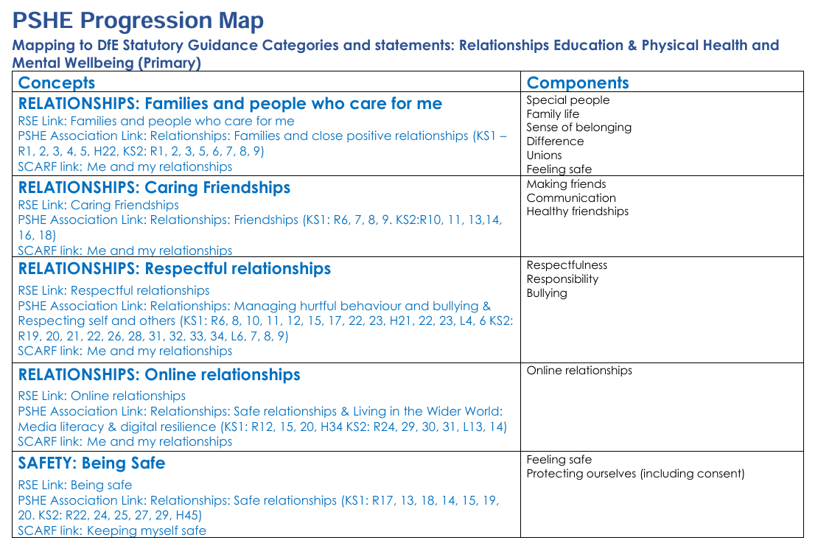
Relationships Education
Families and people who care for me | - That families are important for children growing up safe and happy because they can provide love, security and stability.  - The characteristics of safe and happy family life, such as commitment to each other, including in times of difficulty, protection and care for children and other family members, the importance of spending time together and sharing each other’s lives.  - That the families of other children, either in school or in the wider world, sometimes look different from their family, but that they should respect those differences and know that other children’s families are also characterised by love and care.  - That stable, caring relationships are at the heart of safe and happy families and are important for children’s security as they grow up.  - That marriage and civil partnerships represent a formal and legally recognised commitment of two people to each other which is intended to be lifelong.  - How to recognise if family relationships are making them feel unhappy or unsafe, and how to seek help or advice from others if needed.
Caring friendships | - How important friendships are in making us feel happy and secure, and how people choose and make friends.  - That healthy friendships are positive and welcoming towards others, and do not make others feel lonely or excluded. Pupils should learn skills for developing caring, kind friendships.  - That not every child will have the friends they would like at all times, that most people feel lonely sometimes, and that there is no shame in feeling lonely or talking about it.  - The characteristics of friendships that lead to happiness and security, including mutual respect, honesty, trustworthiness, loyalty, kindness, generosity, trust, sharing interests and experiences, and support with problems and difficulties.  - That most friendships have ups and downs, and that these can often be worked through so that the friendship is repaired or even strengthened.  - How to manage conflict, and that resorting to violence is never right.  - How to recognise when a friendship is making them feel unhappy or uncomfortable, and how to get support when needed.
Respectful, kind relationships | - How to pay attention to the needs and preferences of others, including in families and friendships. Pupils should be encouraged to discuss how we balance the needs and wishes of different people in relationships and why this can be complicated.  - The importance of setting and respecting healthy boundaries in relationships with friends, family, peers and adults.  - How to communicate effectively and manage conflict with kindness and respect; how to be assertive and express needs and boundaries; how to manage feelings, including disappointment and frustration.  - Pupils should have opportunities to discuss the difference between being assertive and being controlling, and conversely the difference between being kind to other people and neglecting your own needs.  - That they can expect to be treated with respect by others, and the importance of respecting others, including those who are different (for example, physically, in character, personality or backgrounds), or make different choices, or have different preferences or beliefs.  - Practical steps they can take and skills they can develop in a range of different contexts to improve or support their relationships.  - The conventions of courtesy and manners.  - The importance of self-respect and how this links to their own happiness. Pupils should have opportunities to think about how they foster their own self-esteem and build a strong sense of their own identity, including through developing skills and interests.  - The different types of bullying (including online bullying), the impact of bullying, responsibilities of bystanders (primarily reporting bullying to an adult), and how to get help.  - What a stereotype is, how stereotypes can be unfair, negative, destructive or lead to bullying and how to challenge a stereotype.  - How to seek help when needed, including when they are concerned about violence, harm, or when they are unsure who to trust.
Online safety and awareness | - That people should be respectful in online interactions, and that the same principles apply to online relationships as to face-to-face relationships, including where people are anonymous. For example, the importance of avoiding putting pressure on others to share information and images online, and strategies for resisting peer pressure.  - How to critically evaluate their online relationships and sources of information, including awareness of the risks associated with people they have never met. For example, that people sometimes behave differently online, including pretending to be someone else, or pretending to be a child, and that this can lead to dangerous situations. How to recognise harmful content or harmful contact, and how to report this.  - That there is a minimum age for joining social media sites (currently 13), which protects children from inappropriate content or unsafe contact with older social media users, who may be strangers, including other children and adults.  - The importance of exercising caution about sharing any information about themselves online. Understanding the importance of privacy and location settings to protect information online.  - Online risks, including that any material provided online might be circulated, and that once a picture or words has been circulated there is no way of deleting it everywhere and no control over where it ends up.  - That the internet contains a lot of content that can be inappropriate and upsetting for children, and where to go for advice and support when they feel worried or concerned about something they have seen or engaged with online.
Being safe | - What sorts of boundaries are appropriate in friendships with peers and others (including online). This can include learning about boundaries in play and in negotiations about space, toys, books, resources etc.  - The concept of privacy and its implications for both children and adults; including that it is not always right to keep secrets if they relate to being safe.  - That each person’s body belongs to them, and the differences between appropriate and inappropriate or unsafe contact, including physical contact.  - How to respond safely and appropriately to adults they may encounter (in all contexts, including online), including those they do and do not know.  - How to recognise when a relationship is harmful or dangerous, including skills for recognising who to trust and who not to trust.  - How to report abuse, concerns about something seen online or experienced in real life, or feelings of being unsafe or feeling bad about any adult and the vocabulary and confidence needed to do so.  - How to ask for advice or help for themselves or others, and to keep trying until they are heard. Where to get advice e.g. family, school and/or other sources.

Sex Education –
The Curriculum for science covers:
- Naming the main external parts of the human body.
- The human body as it grows from birth to old age (including puberty).
- Processes of reproduction and growth in animals; and
- Reproduction in some plants.
Resources
PSHE Association Programme of Study for PSHE Education (Key stages 1–5), Jan 2020.pdf
Harefield Primary School - PSHE

External providers
Choices Program - www.artswork.org.uk

Appendix 3 Health education primary stage curriculum and outcomes
General wellbeing | - The benefits of physical activity, time outdoors, and helping others for health, wellbeing and happiness. Simple self-care techniques, including the importance of rest, time spent with friends and family, as well as hobbies, interests and community participation.  - The importance of promoting general wellbeing and physical health.  - The range and scale of emotions (e.g. happiness, sadness, anger, fear, surprise, nervousness) that they might experience in different situations. Pupils should understand that worrying and feeling down are normal, affect everyone at different times, and are not in themselves a sign of a mental health condition.  - How to recognise feelings and use varied vocabulary to talk about their own and others’ feelings.  - How to judge whether what they are feeling and how they are behaving is appropriate and proportionate.  - That isolation and loneliness can affect children, and the benefits of seeking support.  - That bullying (including cyberbullying) has a negative and often lasting impact on mental wellbeing and how to seek help for themselves or others.  - That change and loss, including bereavement, can provoke a range of feelings, that grief is a natural response to bereavement, and that everyone grieves differently.  - Where and how to seek support (including recognising the triggers for seeking support), including who in school they should speak to if they are worried about their own or someone else’s mental wellbeing or ability to control their emotions (including issues arising online).  - That it is common to experience mental health problems, and early support can help.
Wellbeing online | - That for almost everyone the internet is an integral part of life. Pupils should be supported to think about positive and negative aspects of the internet.  - Pupils should be supported to discuss how online relationships can complement and support meaningful in-person relationships, but also how they might be in tension, and the reasons why online relationships are unlikely to be a good substitute for high quality in-person relationships, looking at the pros and cons of different ways of using online connection.  - The benefits of limiting time spent online, the risks of excessive time spent on electronic devices and the impact of positive and negative content online on their own and others’ mental and physical wellbeing.  - How to consider the impact of their online behaviour on others, and how to recognise and display respectful behaviour online.  - Why social media, some apps, computer games and online gaming, including gambling sites, are age restricted.  - The risks relating to online gaming, video game monetisation, scams, fraud and other financial harms, and that gaming can become addictive.  - How to take a critical approach to what they see and read online and make responsible decisions about which content, including content on social media and apps, is appropriate for them.  - That abuse, bullying and harassment can take place online and that this can impact wellbeing. How to seek support from trusted adults.  - How to understand the information they find online, including from search engines, and know how information is selected and targeted.  - That they have rights in relation to sharing personal data, privacy and consent.  - Where and how to report concerns and get support with issues online.
Physical health and fitness | - The characteristics and mental and physical benefits of an active lifestyle.  - The importance of building regular physical activity into daily and weekly routines and how to achieve this; for example, walking or cycling to school, a daily active mile or other forms of regular, moderate and/or vigorous physical activity.  - The risks associated with an inactive lifestyle, including obesity.  - How and when to seek support including which adults to speak to in school if they are worried about their health.
Healthy eating | - What constitutes a healthy diet (including understanding calories and other nutritional content).  - Understanding the importance of a healthy relationship with food.  - The principles of planning and preparing a range of healthy meals.  - The characteristics of a poor diet and risks associated with unhealthy eating (including, for example, obesity and tooth decay) and other behaviours (e.g. the impact of alcohol on diet or health).
Drugs, alcohol, tobacco and vaping | - The facts about legal and illegal harmful substances and associated risks, including smoking, vaping, alcohol use and drug-taking. This should include the risks of nicotine addiction, which are also caused by other nicotine products such as nicotine pouches.
Health protection and prevention | - How to recognise early signs of physical illness, such as weight loss, or unexplained changes to the body.  - About safe and unsafe exposure to the sun, and how to reduce the risk of sun damage, including skin cancer.  - The importance of sufficient good quality sleep for health, the amount of sleep recommended for their age, and practical steps for improving sleep, such as not using screens in the bedroom. The impact of poor sleep on weight, mood and ability to learn.  - About dental health and the benefits of good oral hygiene, including brushing teeth twice a day with fluoride toothpaste, cleaning between teeth, and regular checkups at the dentist.  - About personal hygiene and germs including bacteria, viruses, how they are spread and treated, and the importance of handwashing.  - The facts and scientific evidence relating to vaccination and immunisation. The introduction of topics relating to vaccination and immunisation should be aligned with when vaccinations are offered to pupils.
Personal Safety | - About hazards (including fire risks) that may cause harm, injury or risk and ways to reduce risks. 2. How to recognise risk and keep safe around roads, railways, including level crossings, and water, including the water safety code.
Basic first aid | - How to make a clear and efficient call to emergency services if necessary, including the importance of reporting incidents rather than filming them.  - Concepts of basic first aid, for example dealing with common injuries and ailments, including head injuries.
Developing bodies | - About growth and other ways the body can change and develop, particularly during adolescence. This topic should include the human lifecycle, and puberty should be discussed as a stage in this process.  - The correct names of body parts, including the penis, vulva, vagina, testicles, scrotum, nipples. Pupils should understand that all of these parts of the body are private and have skills to understand and express their own boundaries around these body parts.  - The facts about the menstrual cycle, including physical and emotional changes, whilst the average age of the onset of menstruation is twelve, periods can start at eight, so covering this topic before girls’ periods start will help them understand what to expect and avoid distress.

The policy should be read in conjunction with:

• Keeping Children Safe in Education (statutory guidance)
https://www.gov.uk/government/publications/keeping-children-safe-in-education--2
• Respectful School Communities: Self Review and Signposting Tool (a tool to support a whole school approach that promotes respect and discipline) http://educateagainsthate.com/download/36/
• Behaviour and Discipline in Schools (advice for schools, including advice for appropriate behaviour between pupils) https://www.gov.uk/government/publications/behaviour-and-discipline-in-schools
• Equality Act 2010 and schools https://www.gov.uk/government/publications/equality-act-2010-advice-for-schools
• SEND code of practice: 0 to 25 years (statutory guidance) https://www.gov.uk/government/publications/send-code-of-practice-0-to-25
• Alternative Provision (statutory guidance) https://www.gov.uk/government/publications/alternative-provision
• Mental Health and Behaviour in Schools (advice for schools) https://www.gov.uk/government/publications/mental-health-and-behaviour-in-schools--2
• Preventing and Tackling Bullying (advice for schools, including advice on cyberbullying) https://www.gov.uk/government/publications/preventing-and-tackling-bullying
• Sexual violence and sexual harassment between children in schools (advice for schools) https://www.gov.uk/government/publications/sexual-violence-and-sexual-harassment-between-children-in-schools-and-colleges
• The Equality and Human Rights Commission Advice and Guidance (provides advice on avoiding discrimination in a variety of educational contexts) https://www.equalityhumanrights.com/en/advice-and-guidance/
• Promoting Fundamental British Values as part of SMSC in schools (guidance for maintained schools on promoting basic important British values as part of pupils’ spiritual, moral, social and cultural (SMSC)
https://www.gov.uk/government/uploads/system/uploads/attachment_data/file/380595/SMSC_Guidance_Maintained_Schools.pdf
• National Citizen Service guidance for schools https://www.gov.uk/government/publications/national-citizen-service-guidance-for-schools-and-colleges

