

Attendance Policy
Reviewed on |  | 2026/27, Term 1 |  | Review frequency |  | Annual
Next review due |  | 2027/28, Term 1 |  | Template Yes / No |  | Yes
Owner |  | Dir of Education, Secondary |  | Approved by |  | Board of Trustees

History of Policy Changes
Date | Page | Change | Origin of Change
Sep 26 | All / relevant sections | Updated for DfE Working together to improve school attendance, July 2026: revised statutory reference; added technical clarification note; strengthened expectations for vulnerable cohorts, part-time timetables, data analysis, impact evaluation and Trust/LGC oversight; updated attendance coding references for C2, E, Q, Y6 and Y7. | DfE statutory guidance update, July 2026
Sep 25 | All | References to Governing Body changed to Local Governing Committee (LGC) | Annual review
Sep 25 | All | References to Headteacher changed to School Leader | Annual review
Sep 25 | Item 1, Introduction | Addition of para in relation to ‘Good Punctuality’ | Annual review
Sep 25 | Item 5, sub para ‘Responsibilities of School and Staff’ – School | 2nd and 3rd bullets added | Annual review
Sep 25 | Item 5, sub para ‘Responsibilities of School and Staff’ – Parents/Carers and Pupils | Bullet points related to Pupils added | Annual review
Sep 25 | Para 8 | % attendance targets aligned with HET Graduated Response

1. Introduction 4
2. Key Information 5
3. Scope 6
4. Definitions 6
5. Responsibilities 6
Responsibilities of the school and staff 6
Responsibilities of LGC and HET 7
Responsibilities of Parents/Carers and Pupils 8
Responsibilities of Local Authority 8
6. Information for Parents 8
Good and Improving Attendance 8
7. School Strategies to Improve and Support Attendance 9
8. Interventions for Poor and Declining Attendance 9
9. Absence Due to Illness 11
10. Medical Conditions 12
11. Request for Leave of Absence 12
12. Religious Observance 13
13. Welcome Back 13
14. Penalty Notices 13
15. Further Information 15
Process for Leavers 15
Possible Exceptions to Unauthorised Absence 16
Absence through competing at regional, county or national level in sport. 16
Service Families 16
Gypsy Roma and Traveller families 16
16. Link to Other HET Policies 17
17. Monitoring & Review 17
18. Appendix 1 – Coding Guidance 17
19. Appendix 2 - HET Attendance Fundamentals 19
20. Appendix 3 - Attendance Graduated Response 19
21. Appendix 3 - Attendance on a Page (school to replace with contextualised version) 20



Introduction

  - Hamwic Education Trust (HET) believe that all pupils should receive a high quality, enriching, learning experience in a safe and inclusive environment, which promotes excellence through a broad curriculum that prepares them for their future and opens doors to a diverse array of opportunities as well as that all pupils and adults within HET flourish as individuals and together.

  - This policy sets out that we recognise that good attendance (above 96%) and good punctuality is key to good pupil outcomes.

The links between regular attendance, good punctuality and reaching potential attainment and future life opportunities are well researched. For this reason, the school will encourage good attendance and punctuality be robust in monitoring attendance and punctuality data and take action when this falls below the expected level. Good attendance impacts significantly on progress, learning, friendship groups and the child’s overall happiness at school.

Good attendance is important because:

- regular attenders make better progress both socially and academically
- regular attenders find school routines, schoolwork and friendships easier to cope with
- regular attenders find learning more satisfying
- statistics show a direct link between under-achievement and absence below 95%
- regular attenders are more successful in transferring between primary school, secondary school and higher education and training.

Good punctuality is important because:

- lateness can mean lost learning time and gaps in knowledge and understanding
- habits of lateness can be formed and continued in later life
- pupils can feel anxious and embarrassed walking into class late.

We understand that there are many reasons why children may be absent or late for school. Please speak to staff about ways that we can support you with this.

Key Information

Attendance Champion | Sian Carr
Attendance Officers | Claire Comley, Tracy Cocking
School opens | 8.35am
Registration begins | 8.40am
Present mark given until | 8.45am
Late mark given between | 8.45am-9.15am
U code, un-authorised absence, applied after | 9.15am
School closes | 3.15pm
How to report your child absent:
First Day Absence  A child not attending school is considered a safeguarding matter. This is why information about the cause of any absence is always required. | Contact the school office 02380463240, email  info@hpslive.net, use the MCAS app or the school website as soon as possible on the first day of absence and by 9.15am where possible. If contact is not made by the parent/carer, then the school will phone, email and/or text the contacts listed for the child to endeavour to make contact.  If we are unable to make contact or ascertain  sufficient reason for absence, a member of staff may make a home visit.  Records of the above will be made available to social care in the event of any Missing in Education investigation
If your child is absent, we will: | Telephone on the first day of absence if we have not heard from you; this is because we have a duty to ensure your child’s safety as well as their regular school attendance. If we are unable to reach you and do not hear from you by 10am, your child’s absence will be recorded as unauthorised, and we will:  - Invite you into the school to discuss the situation with Sian Carr/Tracy Cocking if absences persist.  - Follow all DfE guidance and our graduated response if absence is unauthorised and attendance falls below 90%.
How to report your child absent:
Third Day Absence | Please note after three days of absence, if your child is not seen and contact has not been established with any of the named parents/carers, the school is required to start child absent from education procedures as per the DfE guidance DfE Child Missing Education Guidelines. We will make all reasonable enquiries to establish contact with parents/carers and the child, including making enquiries to known friends and/or wider family.

Scope
This policy is for all pupils on roll at the school Harefield Primary School.

Definitions
- HR’ in this policy, means Hamwic Education Trust HR.
- ‘Local Governing Committee’ in this policy, where reference is made to the Governing Committee, this means the Local Governing Committee of the school, or the Trust in the case of a school where no Local Governing Committee is present. Where a Governing Committee is not present in a school, or numbers are low, Governors from other schools/partnerships may be used.
- ‘Manager’ in this policy, is anyone as identified in the staffing structure with line management responsibilities.

Responsibilities

Responsibilities of the school and staff
School will:
- Promote and reward good and improving attendance with pupils at all appropriate opportunities.
- Have a dedicated member of the senior leadership team who will have the role of Senior Attendance Champion responsible for improving attendance and punctuality. They are expected to set a clear vision for improving and maintaining good attendance, establish and maintain effective systems for tackling absence and make sure they are followed by all staff and have a strong grasp of absence data to focus the collective efforts of the school. They are responsible for liaising with HET in regard to whole school attendance, severe absence and complex cases.
- Follow the Hamwic Education Trust’s attendance fundamental offer set out in Appendix 2.
- Accurately complete admission and attendance registers.
- Have robust daily processes to follow up absence.
- Regularly monitor data to identify patterns and trends and understand which pupils and pupil cohorts to focus on.
- Liaise with the attendance parents/carers on matters of attendance and punctuality.
- Communicate any concerns or underlying problems that may account for a child’s absence.
- Warmly welcome and support pupils to reengage with learning on their return.
- Work with pupils and their parents to understand and address the reasons for absence, including any in-school barriers to attendance.
- Where out of school barriers are identified, signpost and support access to any required services in the first instance and act as lead practitioner if attendance is the only issue and/or the local threshold for formal early help is not met.
- If the absence persists, take an active part in the multi-agency effort with the local authority and other partners. If a case meets the local threshold for formal early help/family support, this includes conducting the early help assessment and acting as the lead practitioner where all partners agree that the school is the best placed lead service.
- Where absence becomes persistent, put additional targeted support in place to remove any barriers. Where necessary this includes working with partners.
- Where there is a lack of engagement, hold more formal conversations with parents and be clear about the potential need for legal intervention in future.
- Where support is not working, being engaged with or appropriate, work with the local authority on legal intervention.
- Where there are safeguarding concerns, intensify support through a referral to statutory children’s social care.
- Support the HET attendance Fundamentals: see Appendix 2
- Observe and fulfil the responsibilities set out in guidance issued by the Department for Education (Summary table of responsibilities for school attendance (applies from 19 August 2024) (publishing.service.gov.uk) to the extent not covered above or elsewhere in this policy.

Responsibilities of LGC and HET

Governors will regularly review attendance data and help School Leaders focus support on the pupils who need it. Attendance data is shared with Trustees x6 times per year.

Responsibilities of Parents/Carers and Pupils

Ensuring your child’s regular attendance at school is a parent/carer’s legal responsibility (Section 444 of the 1996 Education Act) and permitting absence from school that is not authorised by the school creates an offence in law.
Parents/Carers will:
- Inform the school on the first day of absence
- Discuss with the class teacher or attendance staff any planned absences
- Discuss with the class teacher or attendance staff if they need any support to help their child to attend.
- Support the school with their aim to improve attendance
- Make sure that any absence is clearly accounted for by reporting via MCAS app, calling the school or emailing attendance@hpslive.net on the first day and subsequent days of absence
- Avoid taking their children out of school for non-urgent medical or dental appointments.
- Only request leave of absence in very exceptional circumstances.

Pupils will:

- Attend every day that they are able
- Attend school on time
- Attend ready to learn

Responsibilities of Local Authority

Local Authorities will:

- Have a strategy to improve attendance for their whole area.
- Have an Attendance Support Team to work with all schools in the area.
- Provide a named point of contact. Provide opportunities for sharing effective practice.
- Hold termly conversations with every school around attendance.
- Work jointly with schools and relevant agencies to facilitate support for families and remove barriers to attendance particularly for those pupils who are missing out on education.

Information for Parents

Good and Improving Attendance

We will recognise the effort that families make to get pupils into school each day by rewarding good and improving attendance at every opportunity.

Each week, the class with the highest attendance will be rewarded in Celebration Assembly. Children with improved attendance will be invited to be Attendance Ambassadors.

School Strategies to Improve and Support Attendance
The school will follow the DfE guidance below outlined in Working together to improve school attendance (applies from 19 August 2024) (publishing.service.gov.uk)
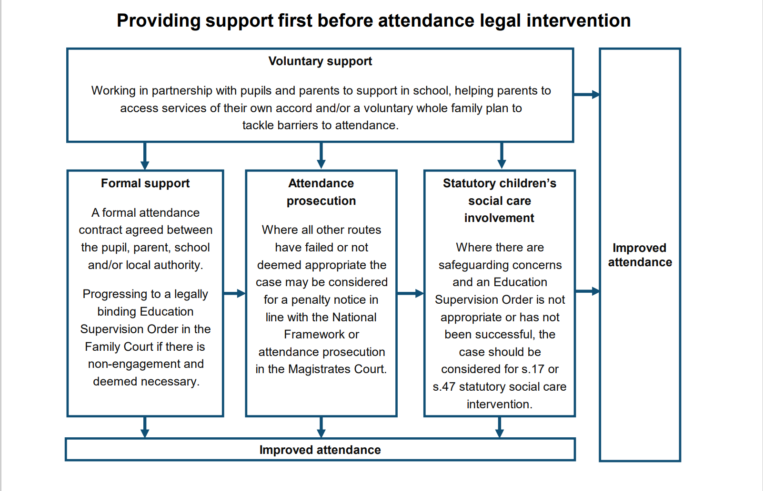

Interventions for Poor and Declining Attendance

The school will use data to target attendance improvement efforts to the pupils or groups of pupils who need it most. In doing so, the School, led by the Senior Attendance Champion, will:

- Monitor and analyse weekly attendance patterns, proactively using data to identify pupils at risk of poor attendance.
- Regularly reference DfE VYED data and reports.
- Provide regular attendance reports to class teachers and relevant leaders.
- Identify pupils who need support from wider partners, as soon as possible, and deliver this support in a targeted manner.
- Conduct thorough analysis of half-termly, termly and full‑year data to identify patterns and trends.
- Benchmark school attendance data at each level against local, regional and national level.
- Monitor the impact of school strategies and actions to improve attendance on particular pupils and particular groups.
- Work with the local authority and other local partners to identify groups in need of support.
- Hold regular meetings with the parents or carers of pupils who the school and/or local authority consider to be vulnerable

Our procedures for managing unexplained absences can be found here:
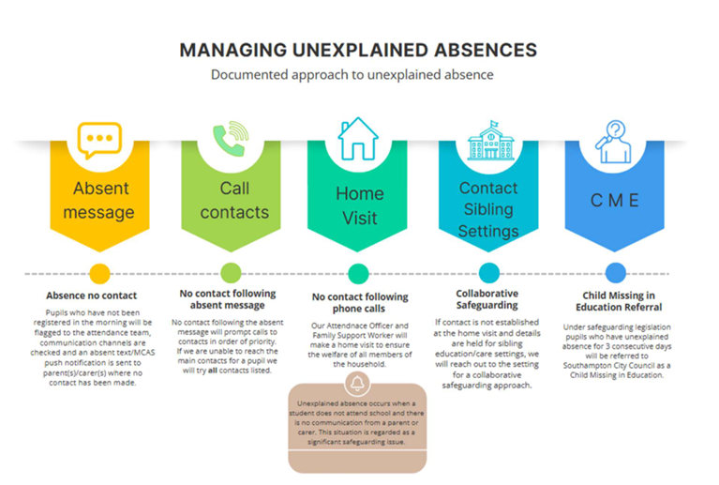

Where absence or punctuality is a cause for concern, for example because there is:

- a pattern of unauthorised absence;
- a question over the reasons provided for a particular absence or late arrival;
- persistent truancy or lateness;
- we will make contact with the parents/carers with a view to working together to support improved attendance and/or punctuality

In cases where the school has been unable to establish a clear reason for absence and/or has welfare concerns about the pupil a home welfare check may be carried out.

The school will follow a graduated response based on the following percentage attendance:

100% attendance: This is excellent attendance

99.9% - 96% attendance: Your child’s attendance is good, and you are giving them the best chance of success.

95 - 93% attendance: Early Intervention Support - Attendance at this level is possibly becoming a concern, will be tracked and monitored and may trigger an intervention to prevent your child becoming persistently absent.

92.9 - 90.1 attendance: Targeted Additional Support - If your child continues to be absent, and their attendance level is falling towards 90%, depending on the reasons for the absence, will contact you to inform you of our next steps.

90 - 80% attendance: Targeted Intensive Additional Support - Your child is considered a Persistent Absentee and attendance is a serious concern. If your child misses 10% (three weeks/30sessions) or more schooling across the school year, for whatever reason, they are defined as persistent absentees. Absence for whatever reason disadvantages a child by creating gaps in their learning. Research shows these gaps affect attainment, social interaction and future earnings. Pupils who are persistently absent will be subject to interventions on a graduated response scale, (see appendix 2) including mandatory reporting to the local authority where there are 10 sessions of consecutive or cumulative absence (session being one of AM or PM) or 15 days of consecutive or cumulative absence marked with an I for illness (this includes illness due to mental health).

79.9 - 50% attendance: Bespoke provision - Your child’s attendance will now be seen as a safeguarding concern

Below 50% attendance: Bespoke provision - Your child’s attendance will now be seen as a serious safeguarding concern. Your child is considered a Severe Absentee and will be subject to intervention from the Local Authority, legal interventions, statutory action including fixed term penalties, court proceedings and possible referral to other outside agencies for a supported return.

Absence Due to Illness

It is recognised that children can become ill and may occasionally need to have time off school. If the school feel that the pupil may need further support with maintaining good health or there are concerns around the number of times the pupil is ill, school may request parents to provide medical evidence to support the family and school in implementing the most effective support.

Letters and recommendations from medical professionals will be considered on a case-by-case basis but will not automatically be seen as a reason to authorise an absence.

Absences due to parents/carers health or medical procedures will not be authorised as standard.

If your child is unwell and you are unsure of whether to send them in to school a useful site to check is https://www.nhs.uk/live-well/healthy-body/is-my-child-too-ill-for-school/

The school may be able to administer some over the counter medications with parental consent, to help your child manage minor illness when in school. This will be decided on a case-by-case basis.

Medical Conditions

Pupils attending our Schools may have medical conditions, either long or short term that will affect their attendance at some stage in their school career. We understand that students with medical conditions are more vulnerable and have greater needs than the majority of their mainstream counterparts. This means that they may have more genuine absences from school for medical reasons or experience greater social needs than others. It is our responsibility as educators to do all we can to encourage and support regular and frequent school attendance whilst they are facing the challenge of ill health and remove the in-school barriers these pupils face, including considering external support and reasonable adjustments, for example, supporting their ongoing learning.

One of our aims is to support children back into school as soon as their health allows because we know that this is best for the child. We aim to help ensure that the reintegration process encourages maximum attendance is resumed as quickly as possible. This includes working with families, ensuring that they understand how important regular attendance is to their child’s development and health. We will support routines where school transport is regularly being missed and work with other partners to encourage the scheduling of additional support interventions or medical appointments outside of the main school day.

It is crucial that our schools receive and fully consider advice from healthcare professionals and listen to and value the views of parents and pupils. We understand that some children with medical conditions may be considered to be disabled under the definition set out in the Equality Act 2010. Some pupils may also have special educational needs (SEN) or Education, Health and Care (EHC) plan which brings together health and social care needs, as well as their special educational provision. We will ensure that staff are properly trained to provide the support that pupils need, their healthcare plan is closely monitored and implement an Individual Healthcare plan if needed. It is at the discretion of the School Leader if they accept a pupil in school if it is judged that the attendance of that pupil maybe at the detriment to their own health or the health of other pupils. The School Leader may seek medical advice where necessary.

Request for Leave of Absence

The DfE states: ‘Head teachers should only authorise leave of absence in exceptional circumstances. If a head teacher grants a leave request, it will be for the head teacher to determine the length of time that the child can be away from school. Leave is unlikely, however, to be granted for the purposes of a family holiday as a norm.’

School Leaders may not grant any leave of absence during term time unless there are exceptional circumstances only and this is not the norm. It is important to note that School Leaders can determine the length of the authorised absence as well as whether the absence is authorised at all.
The fundamental principles for defining ‘exceptional’ are rare, significant, or unavoidable circumstances (which means the event could not reasonably be scheduled at another time). Circumstances will vary from family to family.

There is no legal entitlement for time off in school time to go on holiday and, in the vast majority of cases, holiday will not be authorised.

Parents/Carers wishing to apply for a leave of absence need to fill in an application form (available on request from the school office) in advance and before making any travel arrangements. If term time leave is taken without prior permission from the school, the absence will automatically be unauthorised and if the number of sessions absent exceeds 10 sessions, the school may request the Local Authority to consider issuing a fine or a warning letter.

Taking holidays in term time will affect your child’s schooling as much as any other absence and as such, we expect parents to help us by not arranging holidays during school time. Unauthorised absence of more than 10 sessions (a session being one morning or afternoon) in a ten-week period can be issued with a penalty notice.

School work for pupils that are absent will only be provided during exclusions or long-term medical absences and not during unauthorised absences.

Religious Observance

We recognise that pupils of certain faiths may need to participate in days of religious observance. Where a day of religious observance:
- falls during school time and
- has been exclusively set apart for religious observance by the religious body to which the pupil belongs.
The absence will be authorised. We ask that the parents/carers notify the school in advance

Welcome Back

On returning from absence, all pupils are made to feel welcome, helped to catch up on missed work and brought up to date with any information that has been passed to the other pupils.

Penalty Notices

Penalty Notices may be used under the Local Authority’s Code of Conduct for the use of Penalty Notices in Cases of Non-Attendance at school. A copy of this Code of Conduct can be obtained from the Attendance Officer at the school or the Local Authority. Unauthorised absence of more than 10 sessions (a session being one morning or one afternoon) in a ten-week period can result in a penalty notice. A penalty notice can be issued per parent for each child that is absent. Only two penalty notices will be issued to the same parent for the same child within a 3-year period. Following this the Local Authority can consider instigating Court Proceedings via the Single Justice Procedure. under the new national framework, all schools will be required to consider a fine when a child has missed 10 or more sessions (5 days) for unauthorised reasons. From August 2024, the fine for school absences across the country has been £80 if paid within 21 days, or £160 if paid within 28 days. This rate is in line with inflation and is the first increase since 2012.

In the case of repeated fines, if a parent receives a second fine for the same child within any three-year period, this will be charged at the higher rate of £160. Fines per parent will be capped to two fines within any three-year period. Once this limit has been reached, other action like a parenting order or prosecution will be considered. If you’re prosecuted and attend court because your child hasn’t been attending school, you could get a fine of up to £2,500. Money raised via fines is only used by the local authority to cover the costs of administering the system, and to fund attendance support. Any extra money is returned to the government and does not go to the school.
For more information, please see:

School attendance and support (southampton.gov.uk)

How We Can Support Our Children to Attend

My child is trying to avoid coming to School. What should I do?

Children are sometimes reluctant to attend school. Any problems with regular attendance are best dealt with between the school, the parents and the child.

If a child is reluctant to attend, it is never better to enable them to stay away from school. This may give the impression that attendance does not matter and may make things worse.

Please do contact your child’s class teacher, pastoral worker or attendance staff as soon as possible to openly discuss your worries. Your child could be avoiding school for a number of reasons such as difficulties with schoolwork, friendship problems, family difficulties, special educational needs or bullying issues. It is important that we communicate effectively to identify the reason for your child’s reluctance to attend school and work together to tackle the problem.

In some cases, you may find it helpful to discuss the circumstances of your child’s difficulties with another professional and we may be able to make referrals or signpost you towards further assistance.

What can parents do to encourage their child to attend school?

- Make sure your child gets enough sleep and gets up in plenty of time each morning.
- Ensure that they leave home in the correct clothes and are properly equipped. (contact the school if you require assistance with this)
- Show your child, by your interest, that you value their education.
- Be interested in what your child is doing in school, chat to them about the things they have learnt, their progress towards rewards, their friendships, and even what they had for lunch!
- Speak positively about school at home.

For many parents, a child starting school may be their / your first experience of being separated from them. This can seem daunting at first but thinking and speaking of it as a new and exciting adventure will help you both. The transition into a settled and happy school life also depends on routine and regular, punctual attendance can help as much as any other intervention.

Record Preservation

School registers are legal documents. We will ensure compliance with attendance regulations by keeping attendance records for at least 3 years. Computer registers will be preserved as electronic back-ups.

Criteria for success

- Improved attendance percentage for persistent absentees (10% or higher of their possible sessions missed)
- Improved attendance data across all years.
- Attendance rate increases
- Authorised absence rate decreases
- Unauthorised absence and persistent absence rate decreases
- Improvement in individuals' attendance
- The profile of good attendance within the school community is raised

Further Information

Process for Leavers

If your child is leaving our school (other than when transferring to the secondary school) parents are asked to give the school office comprehensive information about their plans including any date of a move and your new address and telephone numbers, your child’s new school and the start date when known. This should be submitted to our school in writing.
If pupils leave and we do not have the above information, then your child is considered to be a ‘Child Absent from Education.’

This requires schools and Local Authorities to carry out investigations to try and locate your child, which includes liaising with Children’s Services, the Police and other agencies. By giving us the above information, these investigations can be avoided

Possible Exceptions to Unauthorised Absence

The School Leader will consider the impact on learning, the frequency of absence, and whether educational provision is in place during the absence.

Absence through child participation in public performances, including theatre, film or TV Work and modelling

Parents/carers of a child performer can seek leave of absence from school for their child to take part in a performance. They must contact the School Leader to discuss the nature and frequency of the work, whether the child has a valid performance licence and whether education will be provided by the employer during any future leave of absence. Any absence approved by the School Leader as being part of a child’s participation in a public performance is recorded as an authorised absence.

Absence through competing at regional, county or national level in sport.

Parents/carers of able sportsmen and women can seek leave of absence from school for their child to take part in a regional, county, national and international events and competitions. It is however, down to the School Leader’s discretion whether to authorise this. They will wish to discuss with you the nature and frequency of the absence and how learning will continue if absence occurs. Permission for your child to leave early or arrive late to attend coaching and training sessions are also at the discretion of the School Leader and are not likely to be approved if it is a regular event, unless the sports club or association are providing an education tutor as part of their coaching.

Service Families

The Ministry of Defence (MoD) issue additional guidance to schools with regards to term time absences for the children of service families. This is provided because it is acknowledged that the operational needs of the Armed Forces may legitimately prevent a service family from taking holidays within the school holidays. Ultimately the decision on whether to authorise leave in term time still lies with the School Leader, however further clarification regarding the exact circumstances may be sought from Unit Commanding Officers and their welfare staff. When deciding whether to authorise an application for a leave of absence from a service family, the School Leader will take into account the circumstances, the child’s attendance record and the school year which the child is in.

Gypsy Roma and Traveller families

Absence of a child from a traveller family that has left the area may be authorised if the absence is for work purposes only and it is believed that the family intends to return. To ensure the continuity of learning for traveller children, dual registration is allowed. That means that a school cannot remove a traveller child from the school roll while they are travelling. When the traveller is away the home school holds the place open and records the absence as authorised through the T code. Distance Learning packs for traveller children are not an alternative to attendance at school.

Link to Other HET Policies

- Safeguarding and Child Protection Policy
- Children with Medical Conditions who Cannot Attend school policy:

Monitoring & Review

“This policy will be reviewed annually by the HET Attendance Officer and the application will be monitored by the school’s attendance champion, Sian Carr

Appendix 1 – Coding Guidance

Coding Guidance

Summary of the UK school attendance and absence codes along with their meanings and categories, based on the latest guidance effective from August 2024 found here: Working together to improve school attendance

Code | Meaning | Category
/ | Present at morning session | Present
\ | Present at afternoon session | Present
L | Late (before register closes) | Present
B | Attending any other approved educational activity | Approved Educational Activity
D | Dual registered (attending another school) | Approved Educational Activity
K | Attending alternative provision arranged by the LA | Approved Educational Activity
P | Participating in a supervised sporting activity | Approved Educational Activity
V | Educational visit or trip | Approved Educational Activity
J1 | Interview (e.g. for a job or college) | Authorised Absence
C | Leave of absence for exceptional circumstance | Authorised Absence
C1 | Leave of absence for the purpose of participating in a regulated performance or undertaking employment abroad. | Authorised Absence
C2 | Leave of absence for a compulsory school age pupil subject to a part-time timetable | Authorised Absence
E | Excluded but not attending alternative provision | Authorised Absence
I | Illness (not medical/dental appointments) | Authorised Absence
M | Medical/dental appointments | Authorised Absence
R | Religious observance | Authorised Absence
S | Study leave | Authorised Absence
T | Traveller absence | Authorised Absence
G | Family holiday (not agreed or unauthorised) | Unauthorised Absence
N | Reason for absence not yet provided | Unauthorised Absence
O | Absent without authorisation | Unauthorised Absence
U | Late (after register closed) | Unauthorised Absence
X | Not required to be in school (e.g. non-compulsory age, COVID-related) | Not counted in attendance calculations
Y1 | Transport normally provided not being available | Not counted in attendance calculations
Y2 | Widespread disruption to travel | Not counted in attendance calculations
Y3 | School premises partially closed | Not counted in attendance calculations
Y4 | Whole school site being unexpectedly closed | Not counted in attendance calculations
Y5 | Pupil is in criminal justice detention | Not counted in attendance calculations
Y6 | Unable to attend in accordance with public health guidance or law | Not counted in attendance calculations
Y7 | Unable to attend because of any other unavoidable cause | Not counted in attendance calculations
Z | Pupil not yet on roll | Not counted in attendance calculations
# | School closed to pupils | Not counted in attendance calculations
Q | Unable to attend school because of lack of access arrangements | Attendance not required

Appendix 2 - HET Attendance Fundamentals

Appendix 3 - Attendance Graduated Response


Appendix 3 - Attendance on a Page (school to replace with contextualised version)

