

Special Educational Needs and Disability Policy
Harefield Primary School

Reviewed on |  | 2026/27, Term1 |  | Review frequency |  | Annual
Next review due |  | 2027/28, Term 1 |  | Template Yes / No |  | Yes
Owner |  | Dir of Ed, Primary |  | Approved by |  | Board of Trustees

History of Policy Changes

Date | Page | Change | Origin of Change
Sep 26 | All | References to Governing Body changed to Local Governing Committee (LGC) | Annual Review
Sep 26 | All | References to Headteacher changed to School Leader | Annual Review
Sep 26 |  | This review is ‘wholesale’ and the document should be reviewed in its entirety, before approval. | Annual Review

1. Introduction 3
2. Scope 3
3. Aims 3
4. Definitions 3
5. Roles and Responsibilities 4
6. Identification and Assessment of SEN 4
7. Reviewing 5
8. Link to other HET policies 6

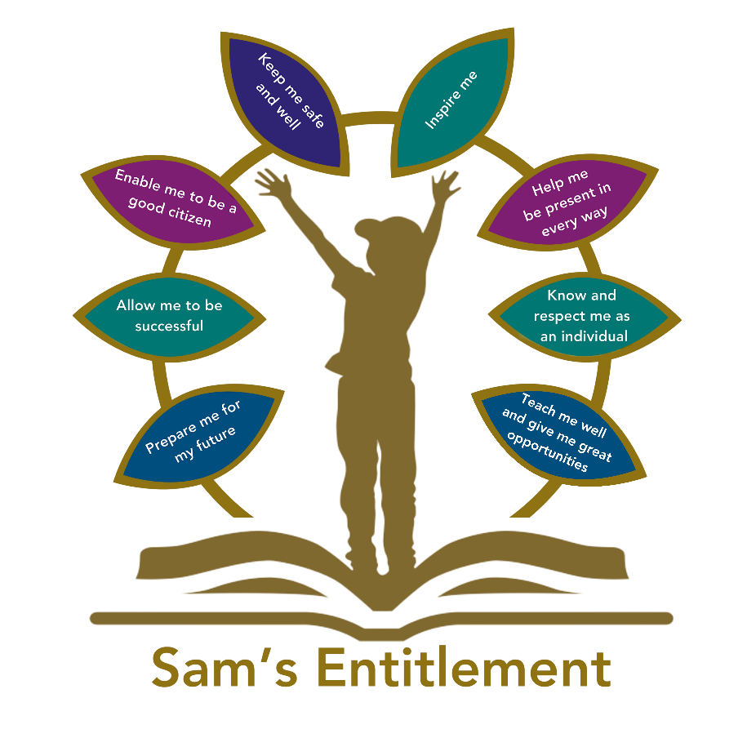

Introduction

Hamwic Education Trust (HET) believe that all pupils should receive a high quality, enriching, learning experience in a safe and inclusive environment, which promotes excellence through a broad curriculum that prepares them for their future and opens doors to a diverse array of opportunities as well as that all pupils and adults within HET flourish as individuals and together.

Scope

This policy is for all employees working within a HET school or establishment (which for ease of reference are referred to throughout this document as ‘schools’) or the HET Managed Service (MS) Team.

It does not apply to agency workers, consultants, self-employed contractors, volunteers or work experience students.

Aims

3.1 All academies within the Trust share common values and an ethos that that all our pupils receive a high-quality, enriching learning experience in a safe and inclusive environment. The SEND policy aims to strengthen and work with our communities to continue to ensure that all students receive their entitlement to a quality education, one that is appropriate to their individual needs, and promotes high standards and the fulfilment of potential. Our support for all children within our care extends to those children with additional needs that require assistance to help them fulfil their potential.

3.2 Each HET school shall ensure that:

- Pupils will not be labelled or disadvantaged by any policy or procedure operated within the Trust.
- It works in partnership with parents and appropriate external agencies to support students with special educational needs and will use its best endeavours to ensure that appropriate provision is secured for any pupil with special educational needs to achieve agreed outcomes.
- It has a Special Educational Needs Coordinator (SENCO). The SENCO will maintain and regularly review the SEN register held in respective of an individual pupil and coordinate support; however, it will be the responsibility of all staff to support individual pupils, to implement strategies suggested by the SENCO, and generally be responsible for ensuring that pupils receive provision appropriate to their needs and agreed outcomes.
- Children and young people with SEN engage in the activities of the school alongside pupils who do not have SEN

3.3 All support provided and decisions taken have regard to these general principles as well as the legal framework set out in the Children and Families Act 2014, the SEND Regulations 2014, and the SEND Code of Practice 2015.

Definitions

4.1 Under the Children and Families Act 2014, a child/young person will have SEN if they have a learning difficulty or disability which calls for special educational provision to be made for them.

4.2 A child or young person will have a learning difficulty or disability if they have:

- A significantly greater difficulty in learning than the majority of others of the same age.
- A disability that prevents or hinders them from making use of facilities that are generally provided for others of the same age in mainstream schools in England.

4.3 Special educational provision is education or training that is additional to or different from that made generally for other children/young people of the same age by mainstream schools.

Roles and Responsibilities

5.1 The implementation of this policy will be monitored by the Board of Trustees and Local Governing Committees (LGC) and remain under constant review by Directors of Education for Primary and Secondary.

- Each School will appoint a Governor with responsibility for SEN. The SEN Governor will raise SEN issues at LGC meetings, monitor the quality and effectiveness of SEN provision within the School and work with designated senior leaders to develop the SEND policy and provision.
- The School Leader will work with the SENCO and SEN Governor to develop the SEN policy and provision within the school. The School Leader has overall responsibility for the provision and progress of learners with SEND.
- The SENCO will coordinate the School’s approach to SEND provision and will undertake those duties set out in chapter 6 of the SEND Code of Practice 2015.
- Class Teachers are responsible for the progress and development of every pupil in their class and will work with the SENCO and Teaching Assistants (TA) to ensure the “assess, plan, do, review” cycle is appropriately implemented to support any pupil with SEND.

5.2 The School will work in partnership with pupils, teachers, parents and, where appropriate, other external agencies to ensure that individual learning needs are addressed within the context of the school curriculum.

5.3 Parents of pupils with SEN will be able to discuss the needs of their child with their child’s tutor, the progress coordinator/Head of Year or the SENCO.

Identification and Assessment of SEN

6.1 Information about previous special educational needs will usually accompany pupils upon entry to the School and this will be used by the SENCO to make sure appropriate provision is continued. Each school will adhere to HET’s Graduated response for SEND. This guidance ensures that the correct provision at each identification stage is made for [pupils/students].
6.2 This information is collated from the transfer of school files from the previous school or Early Years setting and during transition meetings which are held with all the feeder schools or Early Years Settings in the summer term, before students start at the School. If necessary, a strategy sheet will be drawn up for each student with SEN.
6.4 The assessments taken by pupils on entry include reading and maths.
6.5 Ongoing identification is also completed alongside the School reporting process as data is collected and analysed in all subject areas by [subject leads]. If a pupil has not made expected progress, teachers should consult the HET Graduated response for SEND and identify appropriate next steps. If a member of staff identifies a pupil whose special educational needs are not met by the normal adapted programme of study, then the class teacher will work with the pupil setting clear targets and providing greater adaptation. If the situation improves, then no further action is needed. If there is no improvement, the SENCO will be informed.
6.6 At this point, information will be gathered. The class teacher will inform the parents about the issue and there will be consultation and discussion around the proposed additional support for the pupil, parents and the pupil, where appropriate, will be involved in sharing information and agreeing outcomes. It will be decided whether it is appropriate to further monitor the pupil. An information and monitoring document will be drawn up by the SEN team, with copies shared with all staff concerned with the pupil’s progress.
6.7 If a parent/carer refers their child to the School as they believe their child has special educational needs, they should contact the SENCO, who will undertake investigations and appropriate assessments (with input from the relevant teachers) to see if they are achieving expected levels of progress. If the pupil is not achieving appropriate levels of progress, then internal support will be implemented in accordance with the paragraphs above.
6.8 In all cases, where internal support is not effective in supporting the pupil], in accordance with the HET Graduated response for SEND, school should make a referral to a relevant specialist (e.g. Educational Psychologist) will be completed with the parents’ knowledge, and information and strategies for support shared with all staff.
6.8 If there are no concerns regarding the pupil’s academic progress, then the School will ensure appropriate adaptation continues in the classroom and interventions are put in place if appropriate.
6.10 Contact details for professionals who are able to assess will be provided for parents/carers so they can consider a private assessment. Whenever special educational provision is being made, parents and pupils will be involved in developing and reviewing support plans/strategies.
6.11 All staff teaching pupils on the SEN register will be made aware of the individual needs. Directors of subject and the special needs team will help teachers, when required, to develop techniques to support differentiation and ensure that appropriate resources are available as part of the academy’s professional development programme.

Reviewing

7.1 All pupils, regardless of needs, are set targets. Data collated during the School reporting process is analysed and strategies are put in place to support those that are not achieving as expected. All SEN interventions delivered outside the classroom have Specific, Measurable, Achievable, Relevant and Time-bound targets (SMART) set to ensure that progress is made. These are recorded using Individual Education Plans (IEPs) and are monitored and reviewed against a timeframe agreed within the plan. If expected progress is not made, in accordance with the HET Graduated Response for SEND, the SENCO may refer to a specialist service such as an Educational Psychologist.

7.2 Where, despite the School having taken relevant and purposeful action as set out above to meet the pupil’s needs, they have not made expected progress, the School will consider requesting an Education, Health and Care needs assessment.
7.3 If a pupil has an Education, Health and Care Plan (EHCP), an annual review is held in accordance with legal requirements.
7.4 If, because of appropriate progress, a pupil is removed from the SEN register, the pupil will continue to be monitored through the School’s structured reporting programme by the class teachers and SENCO.

Link to other HET policies

This policy should be read in conjunction with:

  - SEN information report (updated annually).
  - Equality, diversity and inclusion policy.
  - Accessibility plan.
  - Behaviour policy.
  - Supporting pupils with medical conditions policy.

Other policies and guidance.

  - HET Graduated Response for SEND
  - Intimate Care policy

