

Intimate Care Policy

Reviewed on |  | Aug 2026 |  | Review frequency |  | Annually
Next review due |  | Aug 2027 |  | Template Yes / No |  | yes
Owner |  | Claire Palmer |  | Approved by |  | Executive

History of Policy Changes
Date | Page | Change | Origin of Change
23.7.26 | 1 | Claire Harvey changed to Claire Palmer | Change of name through marriage.
29.7.26 | 3 | Strengthened reference against discrimination | SEND code of practice and Equalities Act 2010
23.7.26 | 4 | Intimate care definition matched to NSPCC | NSPCC website
29.7.26 | 4 | Insert paragraph under section 6 – strengthening the link between intimate care, privacy and safeguarding the child’s needs. | (EYFS statutory framework, section 3.88; Education Act 2002, section 175; Keeping Children Safe in Education, safeguarding expectations
23.7.26 | 5 | Updated link and reference section | EYFS Statutory Framework
23.7.26 | 5 | Added link to potty training guide – part of the Government’s “Starting Reception” support resources | The-Potty-Training-Guide.pdf
30.7.26 | 7 | Section 13 – medical conditions referenced | Previously physiotherapy

Contents
1. History of Policy Changes 2
2. Contents 2
3. Introduction 3
4. Scope 4
5. Aims 4
6. Legislation and Statutory guidance 4
7. Role of Parents/Carers 5
8. Role of Staff 6
9. How staff will be trained 6
10. Sharing information 6
11. Creating an Intimate Care Plan 6
12. Intimate Care Procedures 7
13. Medical conditions 7
14. Concerns about safeguarding 7
15. Monitoring & Review 8
16. Link to other HET policies (in alphabetical order) 8
17. Appendices 9

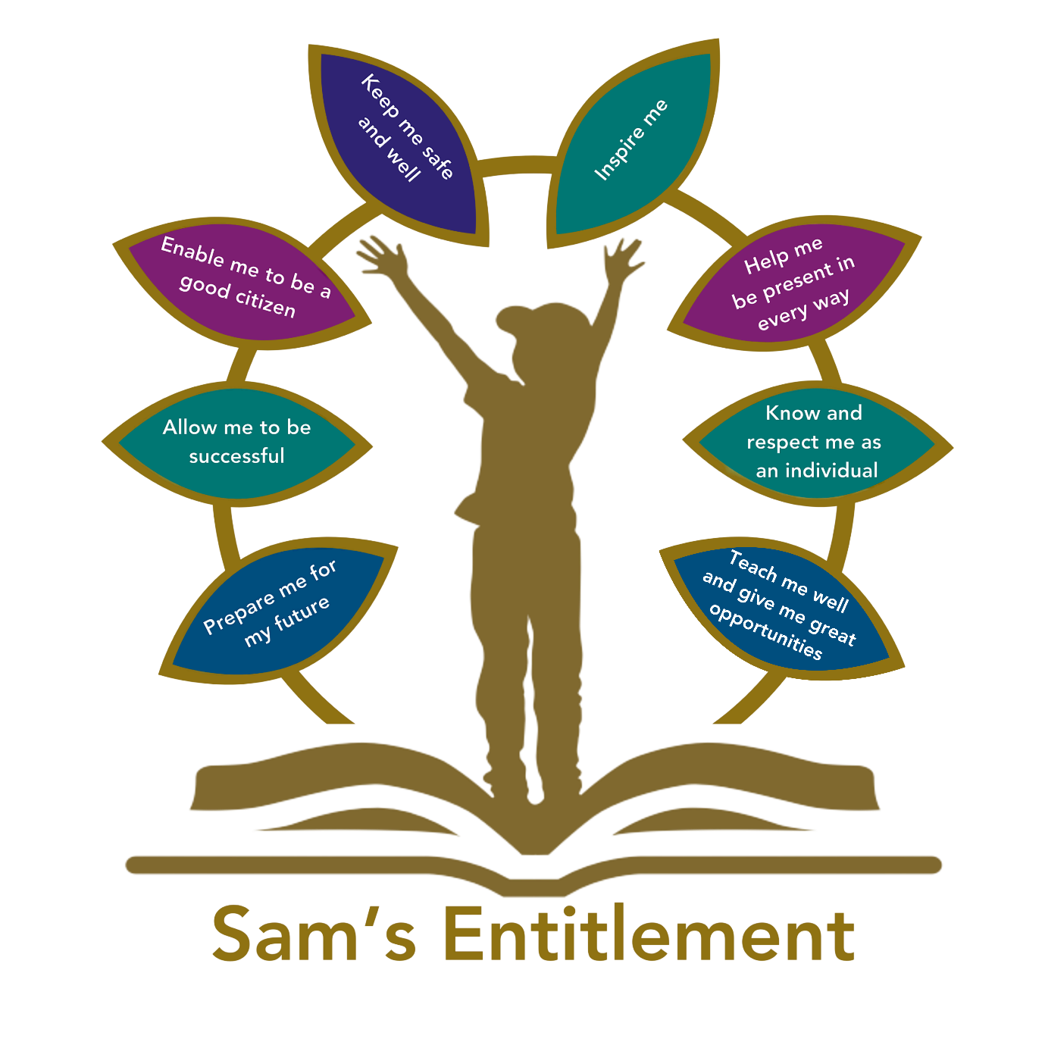

Introduction
“Hamwic Education Trust (HET) believe that all pupils should receive a high quality, enriching, learning experience in a safe and inclusive environment, which promotes excellence through a broad curriculum that prepares them for their future and opens doors to a diverse array of opportunities as well as that all pupils and adults within HET flourish as individuals and together.”

This policy sets out to ensure that:
- Intimate care is carried out properly by staff, in line with any agreed plans
- The dignity, rights and wellbeing of children are safeguarded
- Children who require intimate care must not be discriminated against or treated less favourably because of age, stage of development, disability, SEND or medical need. Where a child’s intimate care needs are linked to disability, SEND or a medical condition, the school will consider reasonable adjustments and agree appropriate support through an intimate care plan, individual healthcare plan, SEN Support plan or EHCP, as relevant.
- Staff carrying out intimate care work do so within guidelines (i.e. health and safety, manual handling, safeguarding protocols awareness) that protect themselves and the child involved.
- Intimate care is a term used to describe activities involved in meeting the personal care needs of a child. It includes providing care which requires direct or indirect contact with, or exposure of, private parts of the body, such as:
- changing nappies, underwear, continence pads or sanitary wear
- helping a child use the toilet
- bathing, showering or washing

Scope
“This policy is for all employees working within a HET school or establishment (which for ease of reference are referred to throughout this document as ‘schools’) or the HET Managed Service (MS) Team.
It does not apply to agency workers, consultants, self-employed contractors, volunteers or work experience students.”

Aims
At times there may be some children across the school who require assistance with intimate care tasks, especially toileting. Other children may also experience difficulties with toileting for a variety of reasons. All the children/young people we work with have the right to be safe, to be treated with courtesy, dignity, and respect. Intimate care can be defined as any care which involves washing, touching or carrying out a procedure to intimate personal areas which most people usually carry out themselves, but some children are unable to do because of their young age, physical difficulties or other special needs. Examples include care associated with continence as well as more ordinary tasks such as help with washing, toileting or dressing.
The purpose of this policy is to set out a clear framework within which all children and young people within the school receive the intimate and personal care they require in order to participate fully in life at school. Harefield Primary School is committed to ensuring that all staff responsible for the intimate care of pupils will undertake their duties in a professional manner at all times. It is acknowledged that these adults are in a position of great trust.
The child’s welfare is of paramount importance and their experience of intimate and personal care should be a positive one. It is essential that every child is treated as an individual and that care is given gently and sensitively; no child should be attended to in a way that causes distress or pain.

Legislation and Statutory guidance
In line with the EYFS statutory framework, the school will ensure that children have access to suitable, hygienic and age-appropriate toilet and changing facilities. Children’s privacy will be respected and balanced carefully with safeguarding requirements. Staff will support children’s developing independence in self-care while ensuring that any intimate care is provided safely, sensitively, hygienically and in accordance with agreed plans, parental communication and safeguarding procedures.
The Governors of Harefield Primary School will act in accordance with Section 175 of the Education Act 2002 and Keeping Children Safe in Education (September 2026) to safeguard and promote the welfare of pupils at this school. This school takes seriously its responsibility to safeguard and promote the welfare of the children and young people in its care. Meeting a child’s intimate care needs is one aspect of safeguarding.
The Local Governing Committee recognises its duties and responsibilities in relation to the following legislation;
- Equality Act (2010)
- The Children Act (1989)
- The Childcare Act (2006)
- UN Convention on the Rights of the Child (1989)
- Health and Safety at Work etc. Act (1974)

September 2026 EYFS statutory framework for group and school-based providers states under “Toilets and intimate hygiene” section 3.88 that providers must ensure:
- There is an adequate number of toilets and hand basins available - there should usually be separate toilet facilities for adults.
- There are suitable hygienic changing facilities for changing any children who are in nappies.
- Children’s privacy is considered and balanced with safeguarding and support needs when changing nappies and toileting.
- There is an adequate supply of clean bedding, towels, spare clothes, and any other necessary items.

Role of Parents/Carers
For children entering Harefield Primary School, their intimate care needs—including toileting support—will be discussed during the school registration process. These discussions will be guided by each child’s age, stage of development, and individual requirements.
Harefield Primary School is committed to supporting children as they progress toward independence in managing their own personal care. Staff will work in partnership with parents and carers to ensure that appropriate strategies and routines are in place to encourage self-care skills in a safe, respectful, and developmentally appropriate manner.
For children starting in Reception, we understand that toilet training can vary based on individual circumstances. If a child is not toilet trained due to a medical condition, we kindly ask parents/carers to provide medical evidence. This helps us to understand the child’s needs and ensure we can offer the most appropriate support.
If there is no identified medical need, or if a child experiences repeated toileting accidents at school, we will work closely with parents/carers to support the child in becoming dry. This may include sharing the Government endorsed The-Potty-Training-Guide.pdf, signposting to external support services, such as the Health Visiting Team, and implementing agreed strategies both at home and in school.
For children who need occasional intimate care (e.g. toileting accidents), school staff will inform parents/carers at the earliest opportunity and will provide appropriate support to maintain dignity and comfort for the child. For children who need routine intimate care, whose needs are more complex or need personalised support, an intimate care plan will be created in discussion with parents.
Where children with complex and/or long-term health conditions have a health care plan in place, the plan should, where relevant, take into account the principles and best practice guidance in this intimate care policy. Where procedures require specialist training, staff undertaking intimate medical care will be given this.
If a pupil without an intimate care plan (or another support plan) has an “accident” whilst at school (e.g. wetting or soiling themselves) and they need help with intimate care, the parents/carers will be contacted and the support needed discussed. Parents of children without intimate care plans record their consent to help children change on BromCom. If consent is not on BromCom parents should be contacted before support is given to the child. (Consent is recorded under annual permissions on the child’s profile page).

Role of Staff
A post holder who is expected to carry out intimate care will normally have this set out in their job description. Where this doesn’t feature in a job description, it can be agreed upon through negotiation. Only paid employees can carry out intimate care, the exception to this being where the parent supports school staff with intimate care. Ordinarily, employees that carry out intimate care must have been subject to an enhanced Disclosure and Barring Service (DBS) with a barred list check before appointment, as well as other checks on their employment history.

How staff will be trained
Staff will receive:
- Training in the specific types of intimate care they undertake (induction and training)
- Regular safeguarding training
- If necessary, manual handling training that enables them to remain safe and for the child to have as much participation as possible

They will be familiar with:
- The control measures set out in risk assessments carried out by the school
- Hygiene and health and safety procedures
- They will also be encouraged to seek further advice as needed.

Sharing information
The school will share information with parents/carers as needed to ensure a consistent approach. It will expect parents/carers to also share relevant information regarding any intimate matters as needed.
If there is a safeguarding concern that arises as a result of intimate care, the school’s safeguarding policy and procedures will be followed.

Creating an Intimate Care Plan
Where an intimate care plan is required, it will be agreed in discussion between the school, parents/carers, the child (when possible) and any relevant health professionals.
The school will work with parents/carers and take their preferences on board to make the process of intimate care as comfortable as possible, dealing with needs sensitively and appropriately. If needed, we will agree appropriate terminology for private parts of the body and functions and note this in the plan. The religious views, beliefs and cultural values of children and their families will be taken into account.
Subject to their age and understanding, the preferences of the child will also be considered. If there’s doubt whether the child is able to make an informed choice, their parents/carers will be consulted.
The plan will be reviewed as necessary whenever there are changes to a child’s needs, but at least annually. In some cases, the support for their intimate care needs will be written into their Education, Health and Care (EHC) plan or their SEN support plan (or equivalent document) rather than an intimate care plan or individual healthcare plan.

Intimate Care Procedures
Nappy changes should be carried out according to the child's individual needs and comfort. For children attending sessions of three hours or less, routine scheduled nappy changes would not normally be expected unless required.
School staff will inform another member of staff when they are going to assist a pupil with intimate care. Staff should follow intimate care plans, and two members of staff should always be present when carrying out intimate care. In exceptional circumstances, it may not be possible for two people to be present, and we will inform parents if this has been the case.
Intimate care procedures for children Harefield Primary School will be carried out in the EYFS changing area, the year group’s toilets or, if inaccessible, the disabled toilets by the school office. If on a trip or visit, care will be carried out in a toilet or an appropriate space. When carrying out procedures, the school will provide staff with protective disposable gloves, disposable apron, cleaning supplies, changing mats and correct bins for disposal. Staff should be fully aware of best practice regarding infection control. The school has 2 nappy bins that are collected weekly for waste to be correctly disposed of.
Staff will always explain or seek the permission of the child before starting an intimate care procedure, according to the child’s age and level of understanding. Children will be supported to do as much as they can for their own intimate care needs, taking into account their age and ability.
For children needing routine intimate care, the school expects parents to provide nappies, wipes, cream and nappy bags. Any soiled clothing will be contained securely, clearly labelled, and discreetly returned to parents at the end of the day.
Accurate records will also be kept when a child receives intimate care. These will be brief but will include date, time and any comments, such as changes in the child’s behaviour. It will be clear who was present in every case.
Not all equipment above will necessarily be used on every occasion but will rather be in line with the agreed care plan. Parents/carers, for example, may provide their own choice of cleaning products for staff to use.
Where a child is in nappies, parents/carers will be responsible for ensuring the school has a supply of nappies, wipes and nappy bags. Parents of children who regularly soil themselves will be required to provide a change of clothes. For children needing routine intimate care, the school expects parents/carers to provide, when necessary, a good stock (at least a week’s worth in advance) of necessary resources, such as nappies, underwear and/or a spare set of clothing.

Medical conditions
Where a child requires physiotherapy, postural support, moving and handling, or other health-related procedures, these will be managed through the child’s individual healthcare plan, SEN Support plan or EHCP, as appropriate, and in line with the school’s medical conditions, moving and handling, health and safety and safeguarding policies. Where any such procedure also involves intimate care, privacy, undressing, toileting or personal hygiene, the principles of this intimate care policy will also apply.

Concerns about safeguarding
If a member of staff carrying out intimate care has concerns about physical changes in a child’s appearance (e.g. marks, bruises, soreness), they will report this using the school’s safeguarding procedures.
If a child is hurt accidentally or there is an issue when carrying out the procedure, the staff member will report the incident immediately to the DSL.
If a child makes an allegation against a member of staff, the responsibility for intimate care of that child will be given to another member of staff as quickly as possible and the allegation will be investigated according to the school’s safeguarding procedures.
If a member of staff has concerns about an adult carrying out intimate care, these should be escalated to the DSL (or deputy DSLs) as soon as they arise

Monitoring & Review
This policy will be reviewed by the DSL and Headteacher annually. At every review the policy will be ratified by the governors.

Link to other HET policies (in alphabetical order)
This policy links with the following policies and procedures:
- Behaviour management
- Health and Safety
- Managing Concerns and allegations against employees
- Managing Medical conditions in school
- Moving and handling
- Physical intervention
- Safeguarding & child protection
- Staff code of conduct and guidance on safer working practice / staff handbook
- Statement of procedures for dealing with allegations of abuse against staff

Appendices
 | Intimate Care Plan
Child name and year group

Type of intimate care needed
How often will care be needed
Details of assistance needed
Where care will take place

What training staff will be given

Additional information about this plan

What resources and equipment will be used, and who will provide them
Staff who are able to carry out care needed.
Name of senior member of staff responsible for ensuring care is carried out according to the intimate care plan
How procedures will differ if taking place on a trip or outing
Liaison with parents/methods of communication
Working towards independence | School will
Working towards independence | Parent/carer will
Working towards independence | Child will
Staff signature and date

Parent signature and date

