If you are having difficulties accessing bug club on an iPhone or an iPad, you may need to change your settings. Please see below:

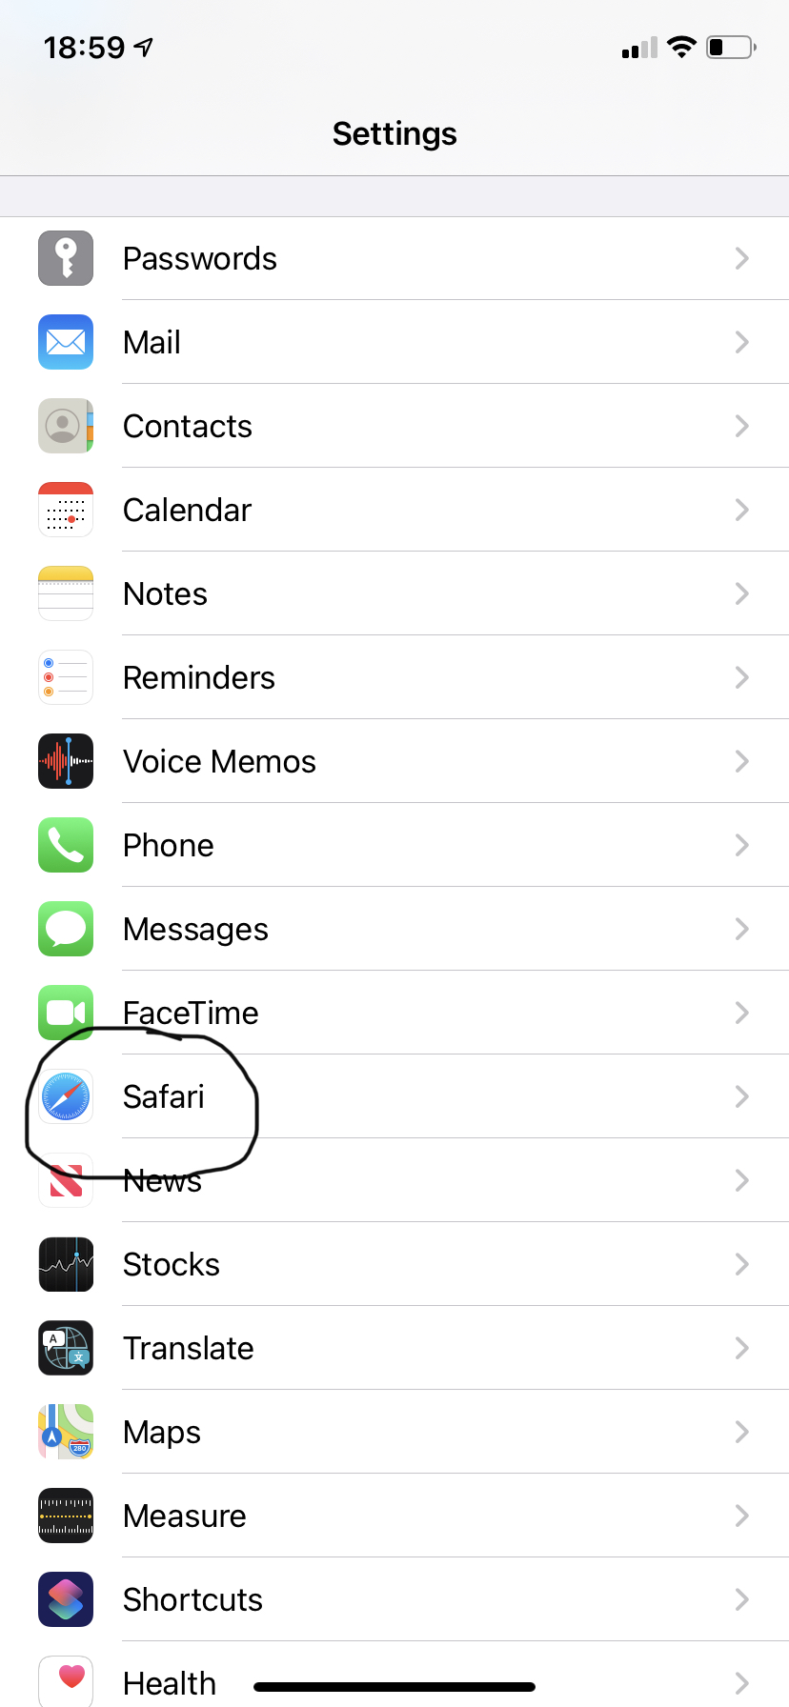
First go to your settings and select safari.

Next check you have both these settings turned off: Block cookies and prevent cross-site tracking.
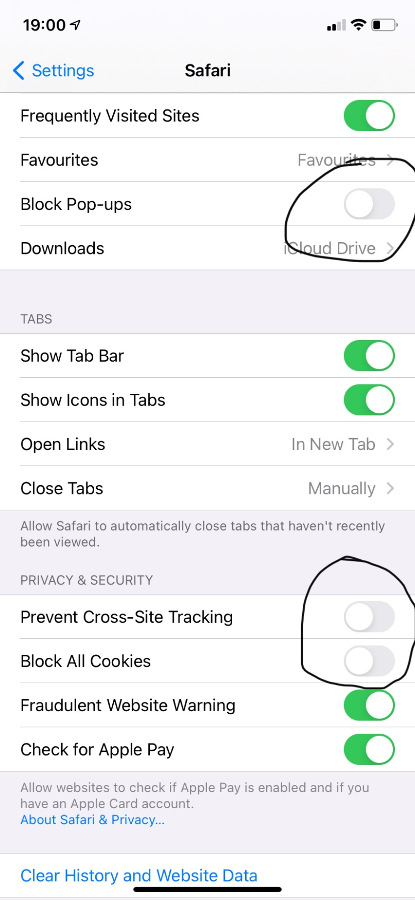

If you have already tried to access bug club, you may need to refresh the log in page before the new settings take effect.
Finally you may be notified that the website is attempting to open a pop-up. Please select allow to see your child’s book.

